Virtual BAS: a physics-grounded, real-world-like building automation system emulator with labelled faults, sensor imperfections and stochastic operation for developing and testing building AI
Liang Zhang^{a,b,}*
a. University of Arizona, Tucson, AZ, USA
b. National Laboratory of the Rockies, Golden, CO, USA
*Corresponding Author: liangzhang1@arizona.edu

Abstract
Artificial intelligence for buildings, from fault detection and diagnosis to reinforcement-learning control and ambient or large-language-model operators, must work on the data of real building automation systems (BAS), where sensors drift, readings go missing, occupants behave randomly and equipment fails. Real BAS data are scarce and lack ground truth, while simulation test beds are usually idealised. This paper presents Virtual BAS, an open-source emulator that couples a step-wise EnergyPlus simulation (the inner space, the physics) with a labelled outer space representing the real world: sensor and actuator models, BAS sequences that act only on observed values, stochastic occupancy and events, and 44 fault and event types on five layers. A local-loop emulation by set-point translation propagates sensor faults physically through loops solved inside EnergyPlus. The clock runs from real time to more than 92,000 times real time, and humans and AI agents inject faults at run time through a web GUI, a REST API, an MCP server and a Gymnasium interface. EnergyPlus models are converted automatically; the DOE reference large office (1207 points on 54 pieces of equipment) is the case study. Beyond typical BAS points, the point list covers the full indoor environment, an extended weather station with forecasts, sub-meters and grid signals, each tagged as standard, advanced or next-generation instrumentation. With ideal sensors, annual results match native EnergyPlus within 0.5% for electricity and 5.2% for natural gas. Experiments demonstrate equipment-level fault impacts, labelled data for fault detection (macro-F1 0.74), AI agents in the loop, a wildfire-smoke episode that a standard BAS cannot observe, and the conversion of five reference buildings. Eighteen uses are identified, spanning AI development, university teaching, operator and facility-manager training, and the testing of commercial analytics products.
Keywords: Building automation system; EnergyPlus co-simulation; Fault injection; Sensor drift; Labelled dataset; Fault detection and diagnosis; Reinforcement learning; Ambient AI; Digital twin; Large language model agents

1 Introduction
Commercial buildings are operated through building automation systems (BAS) that sample hundreds to thousands of points—temperatures, flows, positions, powers, statuses—and execute control sequences on them. These data are the substrate of almost every data-driven building application: automated fault detection and diagnosis (FDD) [1, 2], model predictive and reinforcement-learning (RL) control [3–5], and the recent wave of ambient AI agents and large language model (LLM) operators that are expected to monitor, explain and act on building operation continuously. The development of such methods faces a persistent dilemma. Real BAS data are difficult to obtain, are proprietary and building-specific, and above all have no ground truth: when a supply-air temperature reads 2 K above set point nobody knows whether the coil, the valve, the controller or the sensor is at fault. Physics-based simulation provides ground truth, but simulation test beds are usually idealised: sensors are perfect, data are never missing, the controller sees the true state and nothing breaks. Methods developed in such environments routinely fail when transferred to real buildings, a gap that has been named as one of the central obstacles of RL in buildings [6, 7].
Building simulation test beds have made large progress. BCVTB [8] enabled co-simulation of EnergyPlus [9] with external controllers; the Modelica Buildings library [10] provides component-level dynamic models; BOPTEST [11] defines standardised emulators, key performance indicators and a REST interface for benchmarking control; the Advanced Controls Test Bed [12], Energym [13], Sinergym [14] and CityLearn [15] provide RL-oriented environments. For FDD, EnergyPlus has native fault models [16], fault modelling has been reviewed comprehensively [17], and labelled datasets with faulted and fault-free operation have been published [18, 19] together with a unified fault taxonomy [20]. What is still missing is an environment that behaves like a real BAS as experienced by an AI: one that (i) exposes the equipment-level point list of an actual BAS rather than a reduced observation vector, (ii) places a real-world layer between physics and observation in which sensor drift, noise, data loss and random occupancy are present by default, (iii) lets the BAS controllers act on the wrong values so that the physical consequences of imperfection are simulated rather than added afterwards, (iv) allows anyone—a person, a script, or an AI agent—to inject abnormal conditions while the building runs, at a controllable pace from real time to as fast as possible, and (v) labels everything with mathematically defined ground truth. The datasets cited above are static, and the control test beds are designed to benchmark controllers in idealised, fixed scenarios; to the author’s knowledge none combines these five properties. A sixth requirement follows from field evidence on what BAS actually measure. In 90 buildings with semantic metadata, temperature streams outnumbered power meters by two orders of magnitude, and only 8% of the buildings had the points needed to compute an energy-use intensity [21]; installed CO$​_{2}$ sensors had mean absolute errors of 118–138 ppm [22]. Indoor environmental quality beyond temperature, humidity and CO$​_{2}$ [23], occupant counts and feedback, coil energy meters, actuator feedback and grid signals are rarely available. An emulator should therefore (vi) expose both the instrumentation of today’s BAS and the next-generation points that AI applications need, so that the value of additional sensing can be quantified against ground truth.
The same gap affects people as much as algorithms. Operational problems are pervasive and costly: commissioning of existing buildings, i.e. finding and fixing such problems, yielded a median whole-building energy saving of 16% in a compilation of 643 buildings [24], and correctly implemented and tuned controls, accurate sensors and fault correction could save about 29% of the energy of US commercial buildings [25]. Capturing these savings depends on operators, facility managers, technicians and commissioning agents who can read a BAS and diagnose what it shows. They learn mostly on live buildings, where faults cannot be staged on demand, the true state is unknown, and mistakes affect occupants and equipment. Aviation and nuclear power train and examine their operators on full-scope simulators governed by standards [26], and autonomous driving develops and validates its AI in open simulators before it reaches the road [27]. Building operation has only a few research prototypes of this kind, such as a hybrid simulator connected to a real controller for community-college training [28] and a video game that introduces a university HVAC-control course [29]. Ambient AI and LLM operators [30, 31], which are meant to run continuously beside or instead of a human operator, need such an environment even more: they must be trained, evaluated and stress-tested on realistic BAS behaviour before they are allowed to act on a real building. A realistic, interactive and labelled virtual BAS is therefore a shared infrastructure for AI research, education, workforce training and industry practice (Section 6.1).
This paper introduces Virtual BAS, an open-source framework that is built around a simple separation (Fig. 1). The inner space is an EnergyPlus model advanced step by step through the EnergyPlus Python API [32]; it represents the real physics. The outer space is the real world that surrounds the physics: sensors, actuators, the BAS software, occupants, weather perturbations, faults, operators and AI agents. A canonical example motivates the design: if a zone temperature sensor drifts, the VAV controller does not know it; it controls the drifting reading to set point, computes a wrong air-flow command and sends it to the physical model, so the true zone temperature departs from comfort while the BAS screen shows everything in order. In Virtual BAS this happens exactly so, and both trajectories and the defining equation of the drift are recorded. Fig. 1 follows this loop: the truth $x_{k}$ leaves EnergyPlus on the left, becomes the observed value $y_{k}$ in the sensor models, drives the BAS controllers, passes the priority array, and returns to EnergyPlus as actuator values $a_{k}$. Faults can enter at every box of the loop, and every person or program that interacts with the building does so from the right-hand side, through the same interfaces and with the same priority rules as in a real BAS.
The contributions are:
- A formal inner/outer-space architecture for real-world-like BAS emulation, with mathematically defined sensor, actuator, occupancy and fault models (44 types on five layers) and a complete labelling scheme.
- A local-loop emulation by set-point translation that propagates sensor errors physically through control loops that are solved inside EnergyPlus by ideal local controllers.
- A generic BAS-ization procedure that converts EnergyPlus models into BAS-ready emulators: topology discovery, command binding, physical fault hooks, native control program extraction and semantic point list generation (Project Haystack [33] and Brick [34]) with an availability tier for every point (standard, advanced, next-generation).
- An extended environment layer driven by EnergyPlus air flows and occupants—particle and VOC mass balances, illuminance, sound, occupant feedback, weather forecasts and grid signals—that completes the indoor and outdoor environment a BAS can observe.
- An open-source implementation with a BAS-like web GUI, interactive time control (1$×$ to as fast as possible), BACnet-like priority overrides and five interfaces for humans and AI agents (GUI, scenario files, REST, Model Context Protocol [35], Gymnasium [36]).
- A case study on the DOE reference large office [37] with eight experiments: verification against native EnergyPlus, inner/outer coupling under sensor drift, an equipment-level fault impact matrix, labelled data generation and an FDD benchmark, AI agents in the loop, indoor air quality under wildfire smoke, time-acceleration accuracy, and generality across five reference buildings.
- An analysis of eighteen uses of a virtual BAS across AI research, education and workforce training, industry practice and the research community, each mapped to the features that enable it and to the evidence in this paper.
The remainder is organised as follows. Section 2 reviews related work. Section 3 presents the methodology. Section 4 describes the case study and Section 5 the experiments. Section 6 discusses potential uses and limitations, and Section 7 concludes.
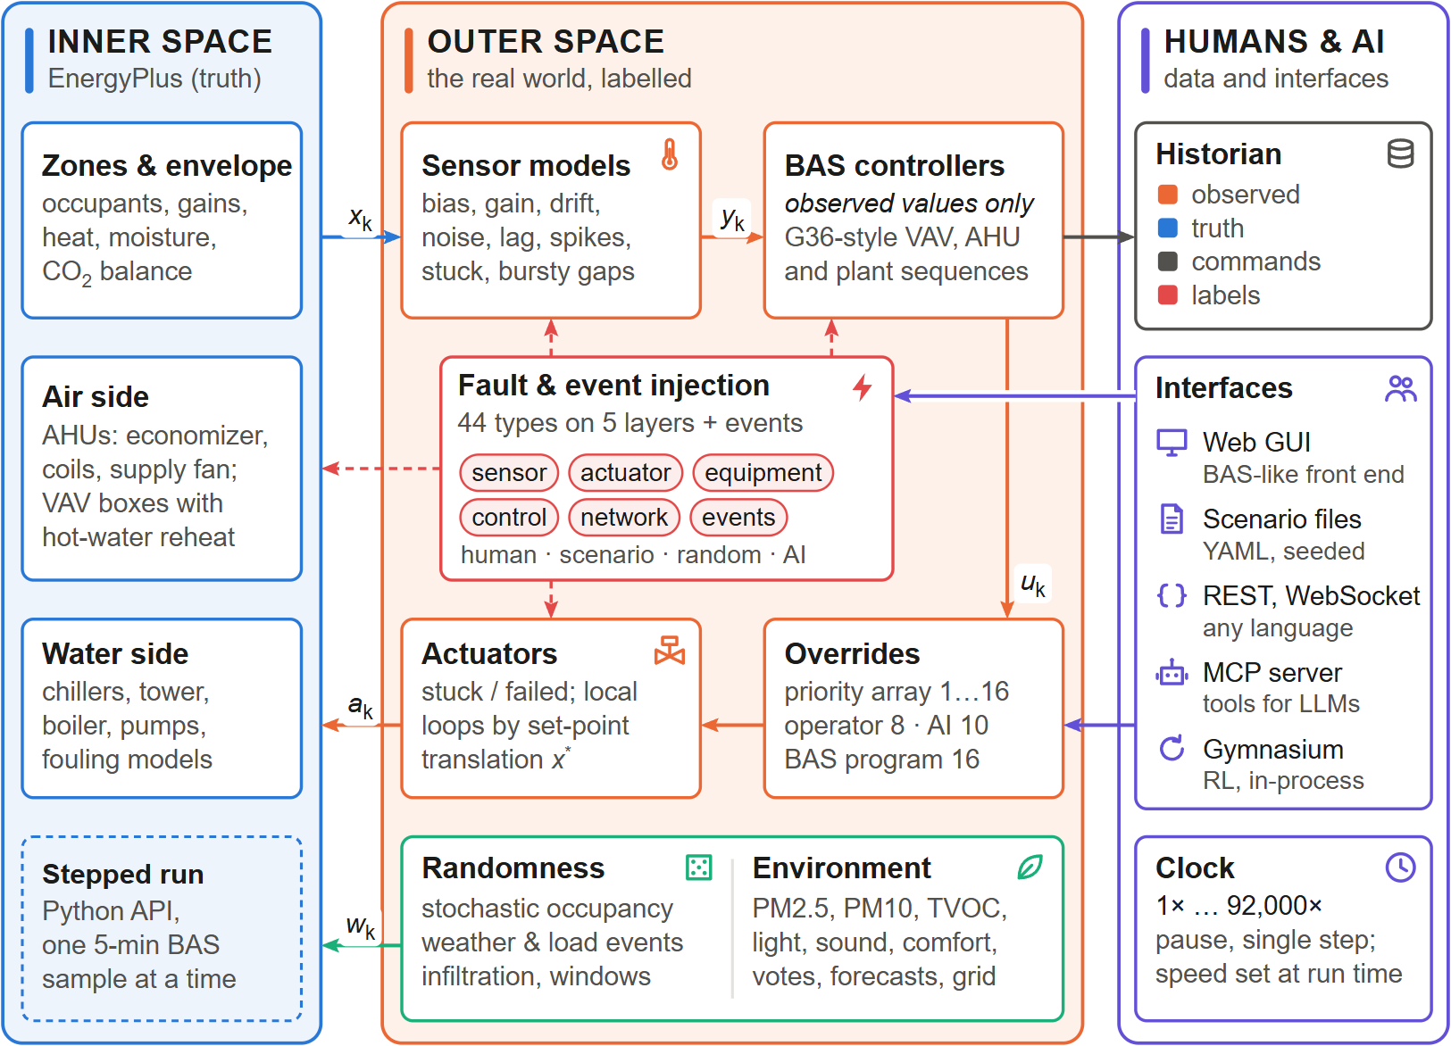
Figure 1: Architecture of Virtual BAS. The inner space (left) is an EnergyPlus model advanced one 5-min BAS sample at a time. The outer space (centre) measures it through sensor models (truth $x_{k}$ $→$ observed $y_{k}$), controls it with BAS sequences that see only observed values, resolves BACnet-like priority overrides ($u_{k}$) and actuates it through actuator models and local-loop emulation ($a_{k}$), while real-world randomness and the environment layer act on the physics ($w_{k}$). Fault and event injection (dashed red) modifies sensors, controllers, actuators and the EnergyPlus physics. Humans and AI agents (right) inject and override through five interfaces; the historian records observed values, truth, commands and labels.

2 Related work
Control test beds. Co-simulation of building models with external controllers dates back to BCVTB [8]. BOPTEST [11] standardised the evaluation of advanced control with high-fidelity Modelica emulators [10], a REST API, baseline controllers and key performance indicators. The Advanced Controls Test Bed [12] connects Spawn-of-EnergyPlus models to Python controllers through the BOPTEST and Alfalfa platforms. Energym [13], Sinergym [14] and CityLearn [15] provide Gym-style interfaces [38] for RL. These frameworks focus on benchmarking controllers in reproducible conditions. They typically expose a selected set of observations and control inputs, treat measurements as exact, and do not provide a library of injectable sensor, actuator, control and network faults during operation. Reviews of RL for buildings [3] and of real-world RL [6, 7] emphasise exactly the missing ingredients: partial and noisy observability, delays, safety constraints, non-stationarity and unexpected events.
Fault modelling and FDD data. Fault modelling for HVAC has been reviewed in [17]. EnergyPlus supports a set of operational faults (sensor offsets, fouling of coils, chillers, boilers, towers and air filters, thermostat offsets) [16]. ASHRAE RP-1312 [18] and the LBNL dataset [19] provide labelled faulted/fault-free data from simulation, laboratory and field, and a unified taxonomy organises HVAC faults [20]. These datasets are invaluable but static: an algorithm cannot interact with them, inject new faults, or close the loop. Classical FDD reviews [1, 2] repeatedly identify the lack of ground-truth data and of test environments with realistic sensor errors as a barrier to deployment.
Semantics and agents. Brick [34] and Project Haystack [33] provide semantic models for BAS points, enabling portable analytics. LLM agents interacting with tools through the Model Context Protocol [35] create a new class of building applications whose evaluation requires an interactive, semantically described BAS with ground truth.
Simulators for education and training. Full-scope training simulators are mandatory in nuclear power [26] and standard in aviation, and open simulators such as CARLA [27] underpin the development of autonomous-driving AI. In buildings, a hybrid simulator that connected a real-time HVAC simulation to a real controller supported a community-college curriculum on control configuration and troubleshooting [28], and a video game based on a building thermal model introduces a university course on HVAC control [29]. These tools teach control principles on simplified systems; none reproduces the point list, graphics, alarms and failure modes of a commercial BAS on a full building with labelled faults.
Gap. Virtual BAS is complementary to the above: it reuses the physics of EnergyPlus and the standard interfaces of RL environments, but its object of emulation is the BAS as a whole—point list, controllers, alarms, historian, operator overrides—embedded in a labelled real-world layer, interactive at any speed, open to fault injection by humans and AI, and obtained automatically from existing EnergyPlus models.

3 Methodology

3.1 Inner and outer space
Let $x_{k}$ be the physical state of the building at BAS sample $k$ as computed by EnergyPlus (the inner space), $y_{k}$ the values reported by the BAS, $u_{k}$ the controller outputs and $a_{k}$ the values written to EnergyPlus actuators. With $θ(t)$ the parameters of the outer space, which are modified by injections, one BAS sample is
$$\begin{aligned}y_{k}&=S\left(x_{k};θ_{S}(t_{k})\right),&u_{k}&=C\left({\hat{y}}_{k};θ_{C}(t_{k})\right), (1) \\ a_{k}&=A\left(u_{k},x_{k};θ_{A}(t_{k})\right),&x_{k+1}&=E\left(x_{k},a_{k},w_{k};θ_{E}(t_{k})\right), (2)\end{aligned}$$
where $S$ is the sensor layer, ${\hat{y}}_{k}$ the BAS present values (last valid sample of $y$), $C$ the BAS control program, $A$ the actuator layer including local-loop emulation, $E$ one EnergyPlus time step with weather and stochastic disturbances $w_{k}$, and $θ_{E}$ the physical fault parameters. The controller never sees $x_{k}$. All quantities $(x_{k},y_{k},u_{k},θ(t_{k}))$ are recorded.

3.2 Step-wise co-simulation and time control
EnergyPlus runs in a worker thread. At the beginning of every zone time step (callback begin system time step before predictor) the runner reads all output variables, meters and internal variables, calls the outer space and writes the returned actuator values. Supervisory plant on/off overrides, which EnergyPlus clears during its HVAC iterations, are re-applied in the inside system iteration loop callback, and weather perturbations are applied when EnergyPlus sets the current weather. EnergyPlus is suspended while the outer space computes, so the simulation is truly stepped. Sizing and warm-up periods are excluded from the BAS time line. Values read at the start of step $k$ refer to the end of step $k-1$, which is the instant at which a BAS samples.
The pace is set by a speed factor $s$ (simulated seconds per wall-clock second). With BAS interval $Δt$ the target wall-clock time of sample $k$ is $τ_{k}=τ_{k-1}+Δt/s$; the runner sleeps until $τ_{k}$ in short slices so that speed changes, pause and single-step requests issued through the GUI or API take effect immediately. $s=∞$ (“max”) runs as fast as possible. Fig. 2 shows the resulting sequence of one sample: EnergyPlus pauses in the API callback (1), queued requests from the interfaces are applied (2), the truth is measured (3), the controllers act on present values (4), overrides are resolved (5) and commands are actuated with set-point translation (6); then everything is recorded (7), the clock is paced (8) and EnergyPlus advances by $Δt$ (9). Because requests are applied only at step 2, an injection or an override issued at any wall-clock time takes effect at a well-defined sample, which makes interactive sessions reproducible.
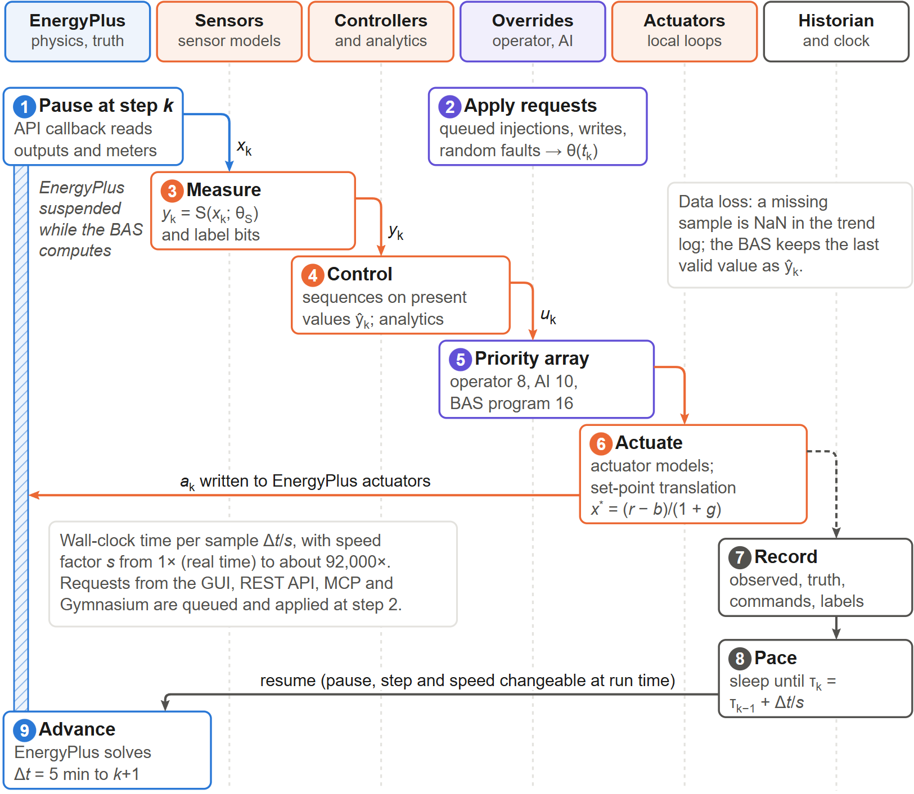
Figure 2: One BAS sample $k$ ($Δt$ = 5 min) as a sequence across the six layers of Virtual BAS. EnergyPlus is suspended (hatched bar) from the API callback (1) until the clock releases it (9); in between, queued requests are applied (2), the truth is measured (3), controllers act on present values (4), overrides are resolved (5), commands are actuated with set-point translation (6), everything is recorded (7) and the wall clock is paced to the speed factor $s$ (8).

3.3 BAS-ization of an EnergyPlus model
A BAS-ready model is obtained from any EnergyPlus model by seven generic stages (Fig. 3) that apply the transformations of Table 1; the shaded strips of the figure give the results for the case study. The HVAC topology is discovered from EnergyPlus’ own connection objects (AirLoopHVAC, branches, supply paths, zone splitters, ZoneHVAC:EquipmentConnections, plant and condenser loops), giving zones, terminal units, air handling units with their outdoor-air system, coils and fan, and plant loops with chillers, boilers, towers and pumps. Every quantity the BAS writes is bound to a dedicated Schedule:Constant (“command schedule”), e.g. a SetpointManager:Scheduled on each AHU supply-air node and plant supply node, the fan availability schedule, and the minimum-flow-fraction schedule of each VAV terminal (input method Scheduled). Because the minimum-flow input method changes EnergyPlus’ autosizing of reheat coils, terminals and reheat coils are first hard-sized with the values of a sizing run of the native configuration. Physical faults are hooked through EnergyPlus FaultModel:Fouling:* objects whose availability and severity schedules are again command schedules. Finally, the native schedules of fans, minimum outdoor air and thermostats are extracted so that the default BAS program reproduces the native operation of the source model.
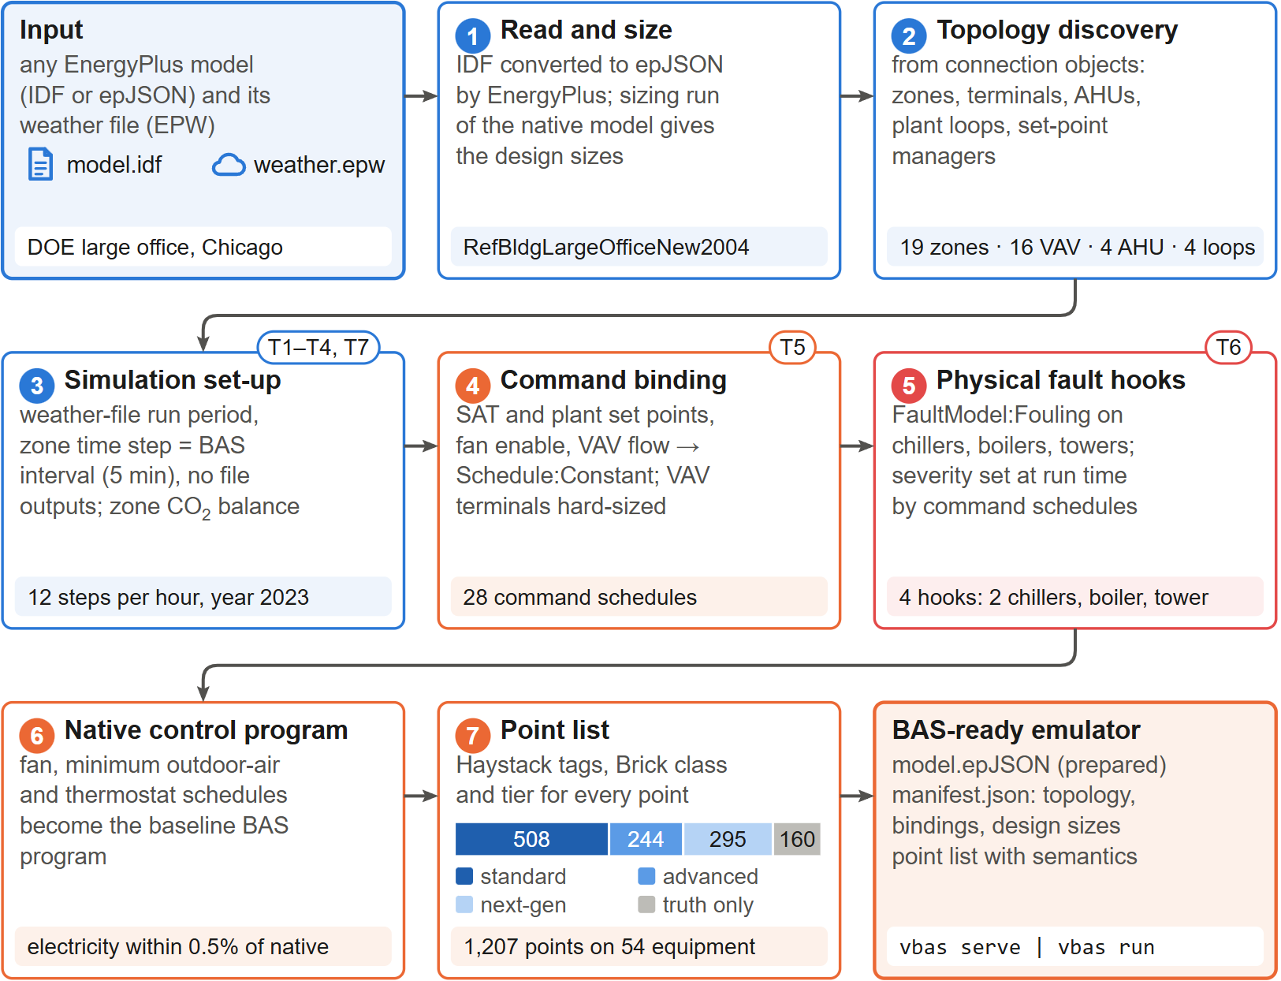
Figure 3: BAS-ization of an EnergyPlus model (vbas prepare). Seven generic stages convert any EnergyPlus model and weather file into a BAS-ready emulator; tags T1–T7 refer to Table 1, and the shaded strips give the results for the DOE large office. The stacked bar in stage 7 shows the availability tiers of the 1207 points.
Table 1: Generic transformations of the BAS-ization procedure.
T1 | Simulation control: sizing performed, weather-file run period only
T2 | Zone time step $=$ BAS sampling interval (default 5 min)
T3 | Run period and calendar year
T4 | Remove file outputs (data are exchanged through the API)
T5 | Command binding: SAT, plant supply temperatures, fan enable, VAV air-flow commands $→$ Schedule:Constant; terminals hard-sized from native sizing
T6 | Physical fault hooks: chiller, boiler and tower fouling models with command schedules
T7 | Zone CO$​_{2}$ mass balance with actuatable outdoor concentration
From the topology a BAS point list is generated: for every piece of equipment the points a commercial BAS would expose (Table 2), each with a stable identifier (AHU-2/SA-T), unit, kind (sensor, setpoint, command, status, meter, virtual), sensor class, Project-Haystack style tags and a Brick class. Each sensor point is bound to an EnergyPlus output variable, meter or derived expression (e.g. valve position as water flow over design flow). Points that a BAS cannot measure but that are useful as labels (true occupant count, coil loads, COP, true outdoor-air fraction, infiltration) are recorded as ground-truth-only points. Duct static pressure, filter and loop differential pressures, which EnergyPlus’ fan and pump models do not resolve, are provided by documented surrogate models, as are chiller refrigerant pressures (saturation temperatures from load- and fouling-dependent approach temperatures and an R-134a vapour-pressure fit), boiler flue temperature and fan and pump vibration.
Every point carries an availability tier. Standard points are those of the ASHRAE Guideline 36 point lists [39], vendor chiller integrations and utility meters; advanced points are found in well-instrumented BAS (actuator position feedback, airflow and water-flow meters, sub-meters, refrigerant-side chiller data, humidity and CO$​_{2}$ in the return air); next-generation points are rarely installed today but valuable for analytics and AI (people counters, particle and VOC monitors, comfort stations, coil energy meters, vibration, weather forecasts, tariff, grid carbon intensity and demand-response signals, occupant votes and complaints). BAS-calculated points (run-hours, start counts, kW/ton, tower approach, 15-min demand, degree-days, outdoor-air fraction from the mixing temperatures, Guideline 36 reset requests) are computed from observed values, so sensor errors propagate into them as in a real BAS. A scenario can restrict the exposed and recorded points to a set of tiers, e.g. to emulate a typical BAS of today while keeping the full ground truth.
Fig. 4 breaks the point list of the case-study building down in this way. Zones and VAV terminals carry most points because they are numerous, but the composition differs: terminal points are mostly standard, whereas the zone points are dominated by next-generation sensing (comfort, particles, VOC, light, sound, people counts and feedback). Only 508 of the 1207 points (42%) belong to the standard tier, i.e. a typical BAS of today would see less than half of what the emulator can expose; 325 points are calculated by the BAS itself from observed values, and 269 take their true value from outer-space or surrogate models rather than from EnergyPlus (Fig. 4c).
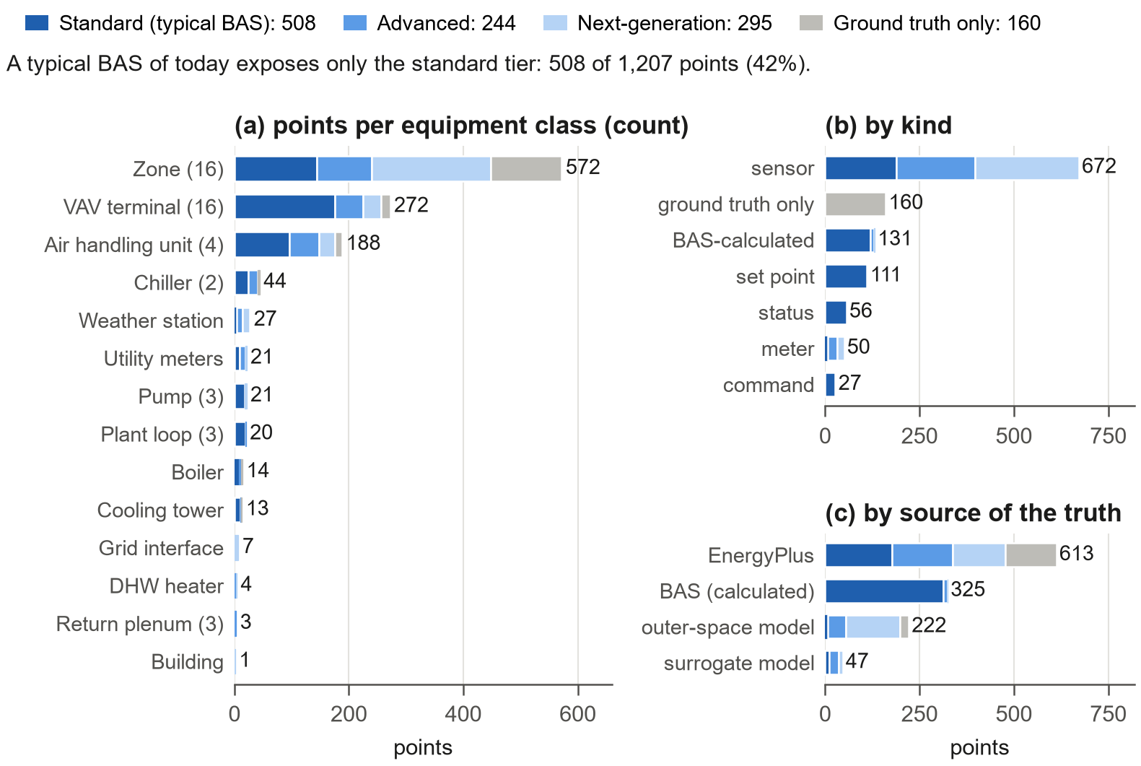
Figure 4: BAS point list of the large office (1207 points) coloured by availability tier: (a) per equipment class (number of units in brackets), (b) by kind and (c) by the source of the true value. A typical BAS of today exposes only the standard tier (42%).
Table 2: BAS points generated for each equipment type (abbreviated); S = standard, A = advanced, N = next-generation tier.
Zone | S: ZN-T, ZN-CO2, ZN-OCC (PIR), heating/cooling set points, occupant set-point adjust; A: ZN-RH, ZN-DP, illuminance, lighting level, window contact, lighting power; N: people count, mean radiant and operative temperature, PMV, PPD, PM2.5, PM10, TVOC, sound level, occupant votes and hot/cold complaints, plug power; truth: occupants, daylight, infiltration, solar and internal gains
VAV box | S: DA-F, DA-F-SP, DA-T, DMPR-CMD, loop outputs, terminal mode, G36 requests, low-flow alarm; A: DMPR-POS, RHV-POS, velocity pressure; N: reheat-coil water flow and energy meter; truth: RH-Q
AHU | S: SA-T, SA-F, MA-T, RA-T, OA-T, OA-F, set points, OAD-CMD, ECON-EN, fan command/status/speed/Hz/power, DSP, FLT-DP, freeze-stat, smoke detector, run-hours, starts, calculated OA fraction; A: SA-RH, SA-DP, RA-RH, RA-CO2, OA-RH, coil leaving-air temperatures, valve/damper feedback, fan current; N: coil water temperatures, flows and energy meters, coil pressure drop, fan vibration; truth: CC-Q, OA fraction
Chiller | S: KW, STS, CHW/CDW entering and leaving temperatures, %RLA, alarm, kW/ton, run-hours, starts; A: load, evaporator/condenser flows, refrigerant saturation temperatures and pressures; truth: PLR, COP
Boiler / tower / pump | S: STS, HW-LWT, HW-EWT, firing rate, alarm / fan power, status, speed, LWT, EWT, approach, range / KW, SPD, Hz, STS; A: load, gas, flow, flue temperature / make-up water; N: pump vibration
Plant loops | CHW-, HW-, CW-: ST, RT, F, DP, ST-SP, $ΔT$; chilled-water tons and plant kW/ton
Weather | S: OA-T, OA-RH, degree-days; A: wet bulb, dew point, enthalpy, humidity ratio, pressure, wind speed and direction, global irradiance, outdoor illuminance, rain; N: direct and diffuse irradiance, sky cover and temperature, precipitation, outdoor PM2.5/PM10, 1/6/24-h forecasts
Meters, grid | S: building electricity and gas demand, water, totalisers, 15-min and peak demand; A: end-use sub-meters (HVAC, lighting, cooling, fans, pumps, heat rejection, heating, exterior lighting, DHW), tower make-up water; N: plug and elevator sub-meters, tariff, carbon intensity, demand-response event, cost and carbon today

3.4 Sensor model
For a physical quantity $x_{k}$ the recorded value is
$$\begin{aligned}{\tilde{x}}_{k}&={\tilde{x}}_{k-1}+\frac{Δt}{τ+Δt}\left(x_{k}-{\tilde{x}}_{k-1}\right), (3) \\ d_{k}&=d_{k-1}+r Δt+ϑ(μ_{d}-d_{k-1}) Δt+σ_{d}\sqrt{Δt} ξ_{k}, (4) \\ z_{k}&=(1+g) {\tilde{x}}_{k}+b+d_{k}+σ_{n}ε_{k}+B_{k}σ_{s}η_{k}, (5) \\ y_{k}&=clip​\left(δ round(z_{k}/δ), y_{min}, y_{max}\right), (6)\end{aligned}$$
with first-order sensor dynamics (time constant $τ$), drift composed of a linear rate $r$ and an Ornstein–Uhlenbeck component [40], installation gain error $g$ and bias $b$, white noise, Bernoulli spikes $B_{k}∼Bern(p_{s})$, quantisation $δ$ and range limits. Two failure modes override the output: a stuck sensor returns the value at the stuck instant, and a missing sample is NaN. Missing data follow a two-state Gilbert–Elliott chain [41, 42] with transition probabilities $p_{gb}$ and $p_{bg}$, producing realistic bursts with stationary loss rate $p_{gb}/(p_{gb}+p_{bg})$. Binary sensors (occupancy, status) use false-on/false-off probabilities. Installation parameters $(b,g,r)$ are drawn once per sensor from data-sheet distributions of 36 sensor classes and scaled by a global realism factor ($0$ = ideal sensors, $1$ = typical commercial hardware). Each sensor uses an independent random stream, so that scenarios with different faults share common random numbers. Fig. 5 illustrates the model.
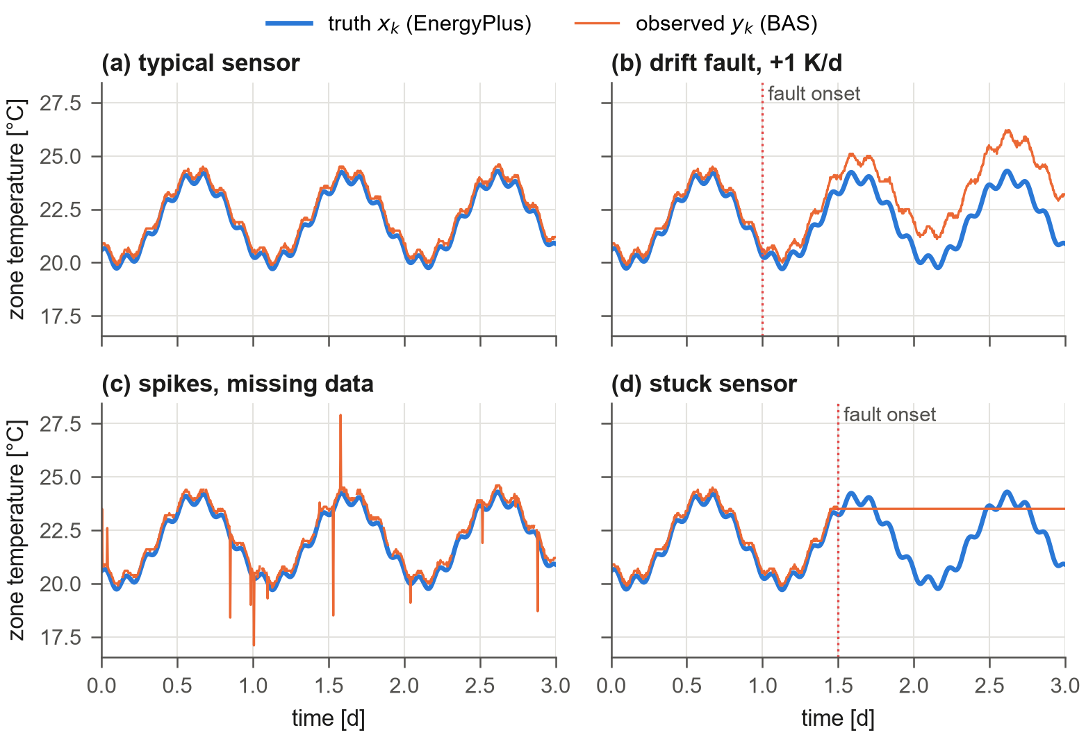
Figure 5: Sensor model output for a zone temperature sensor: typical commercial sensor, drift fault, spikes with bursty missing data, and stuck sensor (dashed: EnergyPlus truth).

3.5 Actuators and local-loop emulation
Explicit BAS outputs (VAV air-flow commands, outdoor-air damper position, fan start/stop) pass through actuator models that can be stuck at a position, failed, or overridden. Some loops, however, are closed inside EnergyPlus by ideal local controllers: the reheat valve to the zone heating set point, the AHU coil valves to the supply-air set point, chillers and boilers to their leaving water temperature, and the VAV box flow loop. A real local loop drives its measured value to the set point $r$. With the deterministic sensor map $y=(1+g)x+b$ (bias plus accumulated drift), the steady state of a loop with integral action satisfies $(1+g)x^{*}+b=r$, hence
$$x^{*}=\frac{r-b}{1+g}. (7)$$
Virtual BAS therefore hands $x^{*}$ instead of $r$ to the ideal EnergyPlus controller (set-point translation, Fig. 6). If the reading is stuck or spoofed at value $v$, the integral action winds up and the actuator saturates: $x^{*}=x_{max}$ if $v<r$ and $x_{min}$ otherwise for a direct process, and the opposite for a reverse (cooling) process. If the reading is unavailable, the loop holds its last output. With Eq. (7) every sensor fault propagates physically, including through loops that the BAS does not compute explicitly.
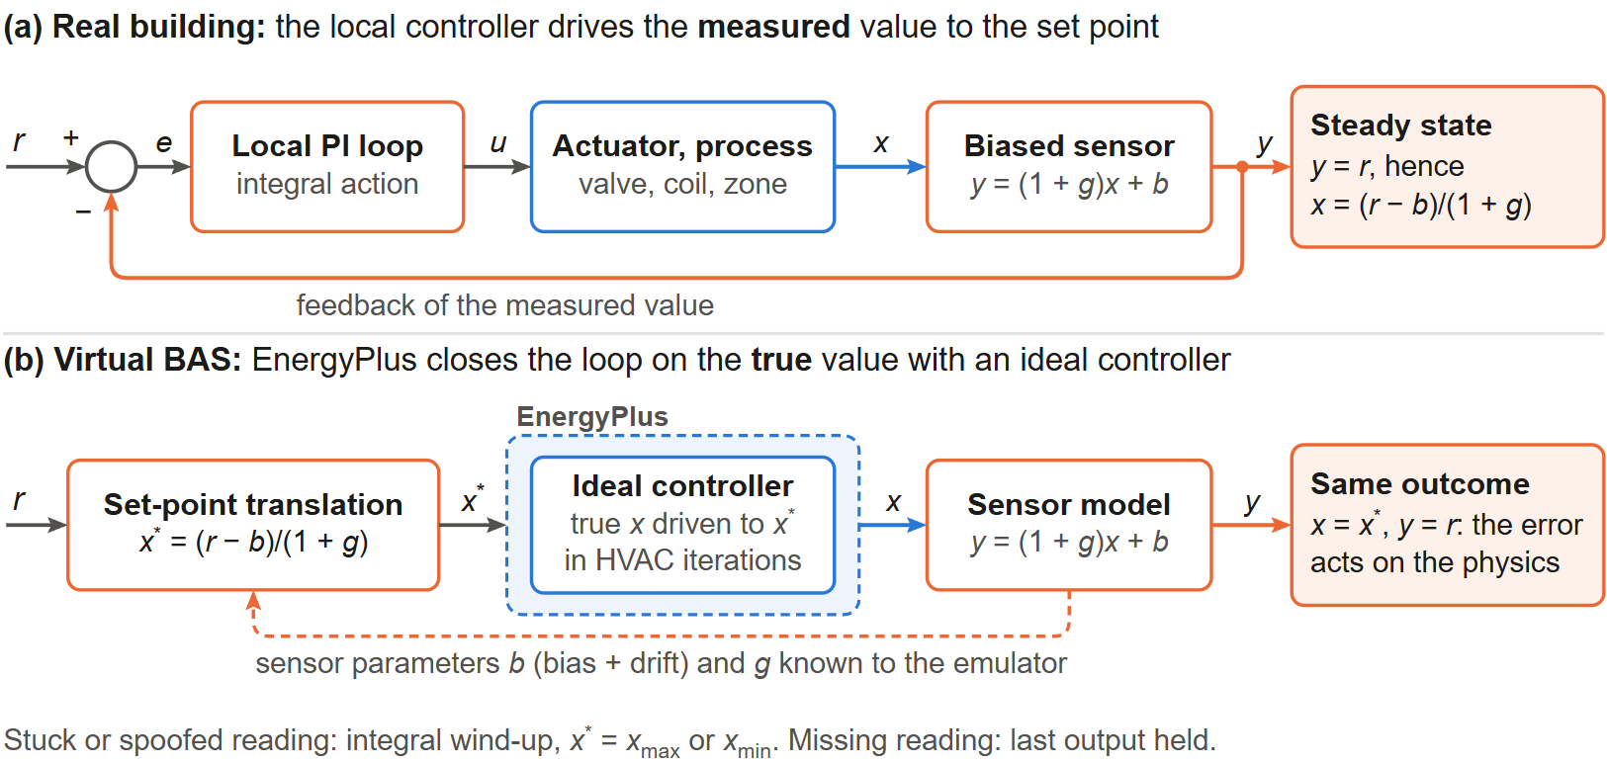
Figure 6: Local-loop emulation by set-point translation. (a) In a real building, a local loop with integral action drives the biased reading $y$ to the set point $r$, so the true value settles at $x=(r-b)/(1+g)$. (b) EnergyPlus solves the loop with an ideal controller on the true value; handing it the translated set point $x^{*}$ reproduces the same physical outcome, so sensor faults propagate into the physics.
The VAV terminals are controlled explicitly: the BAS computes an air-flow set point, the box flow loop is emulated through Eq. (7) applied to the air-flow sensor, and the resulting flow fraction is written to the terminal’s minimum-flow schedule while the EnergyPlus cooling set point of the zone is relaxed, so that EnergyPlus delivers exactly the commanded flow. Reheat is supplied by the reheat local loop. The outdoor-air flow is written to the Controller:OutdoorAir actuator as the commanded outdoor-air fraction times the sum of commanded box flows.

3.6 Real-world randomness
Occupancy. Each zone with $N$ design occupants follows the inhomogeneous Markov model of Page et al. [43], driven by the zone’s EnergyPlus occupancy schedule $P(t)$ scaled by a daily attendance factor $a_{d}∼U(a_{min},1)$:
$$\begin{matrix}T_{01}={μ-1}/{μ+1}P_{k}+P_{k+1}, T_{11}={P_{k}-1}/{P_{k}}\left({μ-1}/{μ+1}P_{k}+P_{k+1}\right)+{P_{k+1}}/{P_{k}}, \\ n_{k+1}=Bin(n_{k},T_{11})+Bin(N-n_{k},T_{01}),\end{matrix}$$
with mobility $μ$. The count is written to the EnergyPlus People actuator, so occupants affect heat gains and CO$​_{2}$; the BAS observes them only through PIR sensors with false-on/false-off rates (Fig. 7). The daily attendance factor makes every day different (Saturday follows a reduced schedule), the PIR sensor reports the same state for five and for 130 people, and on Sunday it produces a few false-on readings although nobody is present.
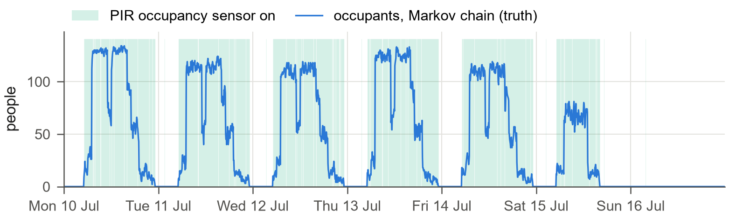
Figure 7: Stochastic occupancy of zone Core_mid during one summer week: number of occupants drawn by the Markov chain (truth, written to the EnergyPlus People actuator) and the periods in which the zone’s PIR sensor reports occupancy to the BAS. Attendance varies from day to day, and the binary sensor hides the head count.
Events. Weather perturbations (heat waves, cold snaps, cloud cover) are applied to the EnergyPlus weather actuators as offsets/multipliers of the weather file; plug and lighting load changes, window opening (additional infiltration), meetings, holidays and outdoor CO$​_{2}$ changes complete the event library.

3.7 Extended indoor and outdoor environment
EnergyPlus solves the heat, moisture and CO$​_{2}$ balances. Quantities that it does not model, but that occupants experience and next-generation BAS measure, are computed in the outer space at every step from the EnergyPlus state, so they remain consistent with the simulated air flows, occupants, lighting power and solar gains.
Particles and VOC. Each zone is a well-mixed volume $V$ supplied with $Q_{s}$ by its terminal and $Q_{i}$ by infiltration:
$$\begin{aligned}V\frac{dC}{dt}&=Q_{s}C_{s}+P Q_{i}C_{o}+S-(Q_{s}+Q_{i}+kV) C, (10) \\ C_{s}&=(1-η)\left(x_{OA}C_{o}+(1-x_{OA}) {\overset{‾}{C}}_{ret}\right),\end{aligned}$$
with outdoor concentration $C_{o}$, penetration factor $P$, deposition or sink rate $k$, indoor source $S$ (occupants, materials, events), the AHU outdoor-air fraction $x_{OA}$ taken from EnergyPlus, filter efficiency $η$ by MERV class [44] and the flow-weighted return concentration ${\overset{‾}{C}}_{ret}$ of the zones served by the AHU. Eq. (10) is integrated exactly over each step for PM2.5, the coarse fraction PM2.5–10 and TVOC (without filtration). Outdoor PM2.5 follows a log-normal Ornstein–Uhlenbeck process with a diurnal traffic cycle; wildfire_smoke, indoor_pollutant_source and filter_bypass injections act on $C_{o}$, $S$ and $η$. Fig. 8 places the mass balance in its context: the supply concentration depends on the AHU’s outdoor-air fraction and filter, the infiltration path bypasses the filter, and the same EnergyPlus state also drives the light, sound, comfort, feedback and occupancy channels described below. The badges give the BAS point that exposes each quantity and its tier; of the quantities shown, only the zone CO$​_{2}$, the PIR occupancy sensor and the filter pressure drop belong to the standard tier.
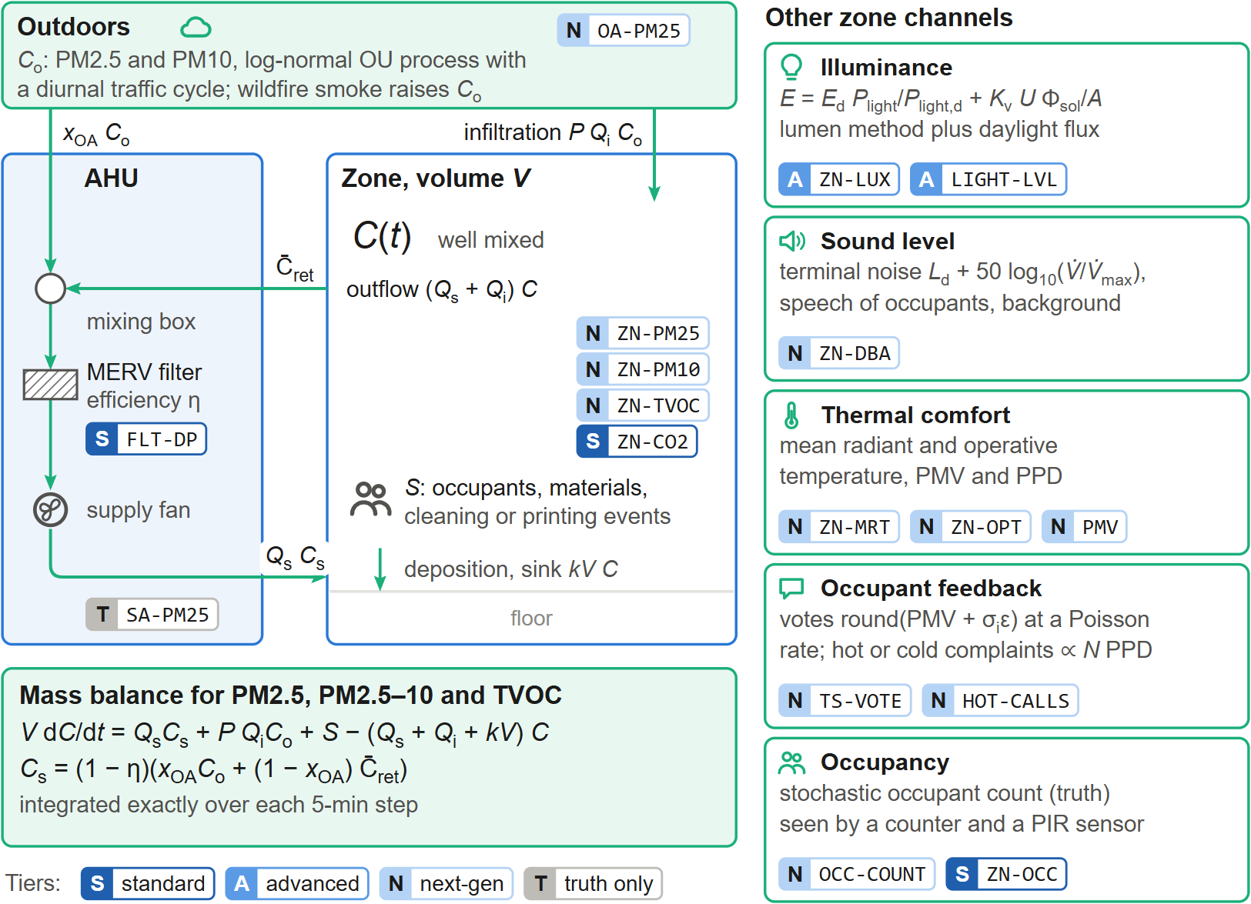
Figure 8: Extended environment of one zone. Particles and TVOC follow a well-mixed mass balance driven by EnergyPlus air flows: supply air through the AHU’s MERV filter, infiltration from outdoors (where wildfire smoke raises $C_{o}$), indoor sources and deposition. Illuminance, sound, comfort, occupant feedback and occupancy are derived from the same EnergyPlus state. Badges give the point identifier and its availability tier (S standard, A advanced, N next-generation, T ground truth only).
Light and sound. Work-plane illuminance combines the lumen method for electric light and the daylight-flux method, $E=E_{d}P_{light}/P_{light,d}+K_{v}UΦ_{sol}/A$, with design illuminance $E_{d}$, luminous efficacy of daylight $K_{v}$, utilisation factor $U$ and the solar flux $Φ_{sol}$ transmitted by the zone’s windows (EnergyPlus). The background sound level is the energetic sum of terminal noise following the fan law ($L_{d}+50\log_{10}(\dot{V}/{\dot{V}}_{max})$), speech scaled by the density of talking occupants, and a background floor.
Comfort and occupant feedback. Mean radiant and operative temperatures and the Fanger PMV and PPD [45] come from EnergyPlus and are exposed as comfort-station points. Occupants submit thermal-sensation votes $round(PMV+σ_{i}ε)$ through a feedback application at a Poisson rate, and file hot or cold complaints at a rate proportional to $N PPD$, split by a logistic function of PMV; votes and complaint counts are BAS points.
Forecasts and grid. An hourly-issued 48-h weather forecast equals the weather file plus errors whose standard deviation grows with lead time, $σ(h)=σ_{0}+σ_{∞}(1-e^{-h/τ})$, and that are AR(1)-correlated between issues. The grid interface provides a time-of-use tariff, a synthetic marginal carbon intensity (diurnal profile, solar dip and AR noise) and demand-response events with a requested shed; cost and carbon are accumulated as KPIs. The forecast is also available as an API call and an MCP tool. Fig. 9 shows these signals for a July week: the forecast follows the weather file closely for the next hours and departs from it by more than 2 K after two days, and its root-mean-square error over 168 hourly issues reproduces the prescribed growth $σ(h)$ (0.8 K at 6 h, 1.6 K at 24 h and 2.4 K at 48 h ahead). The tariff and the carbon intensity peak at different times of day, so that cost-optimal and carbon-optimal operation differ, as in real grids.
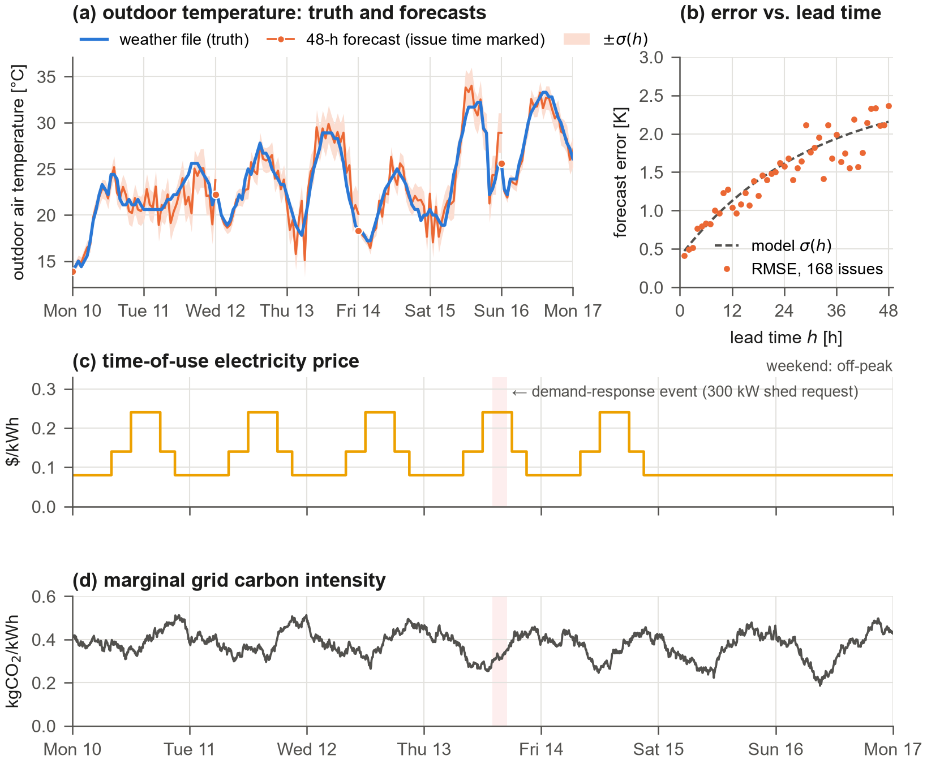
Figure 9: Outdoor and grid signals for a July week. (a) Outdoor temperature of the weather file (truth) and 48-h forecasts issued every two days (dots mark the issue times) with the $±σ(h)$ band; (b) root-mean-square forecast error of 168 hourly issues versus lead time against the model $σ(h)$; (c) time-of-use electricity price and (d) marginal grid carbon intensity, with a demand-response event shaded.
These models are deliberately simple, well documented and parameterised in the building configuration; they make the corresponding points behave plausibly and causally, not reproduce a particular building. In the GUI every zone has an indoor-environment page, and a building heat-map switches between metrics (Fig. 10). The example, taken during the staged smoke episode, shows how the channels interact: the core zone of the middle floors is overcooled by the drifting thermostat, so that its PMV and PPD are poor and its occupants file cold complaints, while its PM2.5 is four times the WHO guideline although no standard BAS point would show it.
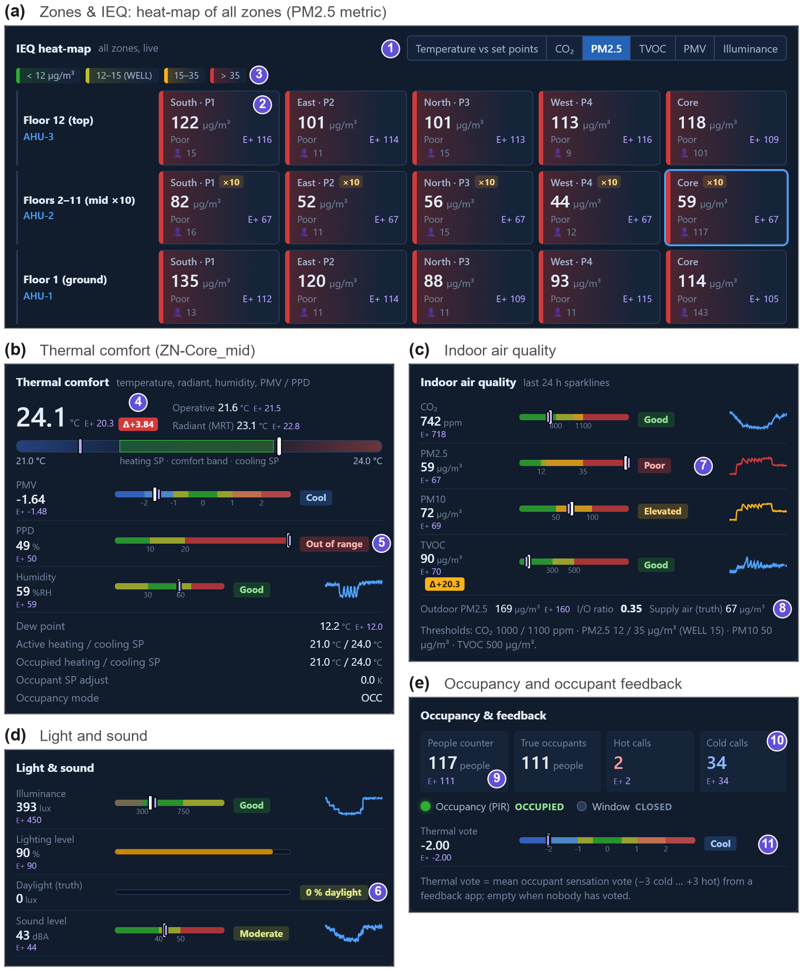
Figure 10: Indoor-environment pages of the GUI during the staged wildfire-smoke episode. (a) Building heat-map on the PM2.5 metric (1–3): every zone exceeds 35 $μ$g/m$​^{3}$. (b)–(e) Detail of zone Core_mid: thermal comfort with the drift-affected temperature (4) and a PPD of 49% (5), indoor air quality with a 24-h sparkline of the smoke onset (7) and the outdoor, indoor and supply-air concentrations (8), light and sound with the truth-only daylight share (6), and occupancy and feedback: a people counter with its own error against the true count (9), cold complaints (10) and the mean thermal-sensation vote (11).

3.8 Faults and injections
All abnormal or random conditions are injections of a registered type. An injection has a target (point, equipment, zone or building), start $t_{0}$, optional end $t_{1}$ and a severity profile
$$s(t)=\left\{\begin{matrix}0 & t<t_{0}\text{ or }t≥t_{1} \\ 1 & \text{step} \\ min​\left(1,(t-t_{0})/T_{r}\right) & \text{ramp (incipient)} \\ 1​\left[((t-t_{0}) mod P)<D P\right] & \text{intermittent}\end{matrix}\right.$$
that modulates one parameter, $θ(t)=θ_{0}+s(t) Δθ$ (Fig. 12b). Fig. 12a shows the library: sensor faults (bias, drift, gain error, noise, stuck value, spikes, dropout and spoofing) apply to any of the sensor points; actuator faults stick dampers and valves or fail the supply fan; equipment faults degrade chillers, boilers, towers, filters and fans or trip plant equipment; control faults corrupt schedules, tuning, economizer and reset logic or freeze a controller; network faults take a controller off-line or stop the historian. Events are not faults but the randomness of a real building—occupancy surges, meetings, holidays, weather changes, wildfire smoke, opened windows, load changes, pollutant sources, demand-response requests and price spikes. In the GUI (Fig. 11) the catalogue is browsable with the defining equation of every type, and the injection form is generated from the type’s parameter specification, so a new fault type needs no GUI code. Equipment faults act inside EnergyPlus: fouling factors of chillers, boilers and towers through the native fault models, filter loading through the fan pressure rise, fan degradation through the fan efficiency actuator, and trips and stuck-closed valves through plant supervisory overrides. New types are registered with a decorator and immediately appear in the GUI, the REST catalog and the MCP tools. A random fault generator draws arrivals from a Poisson process with rate $λ$ per week and samples type, target, magnitude and duration from configurable distributions.
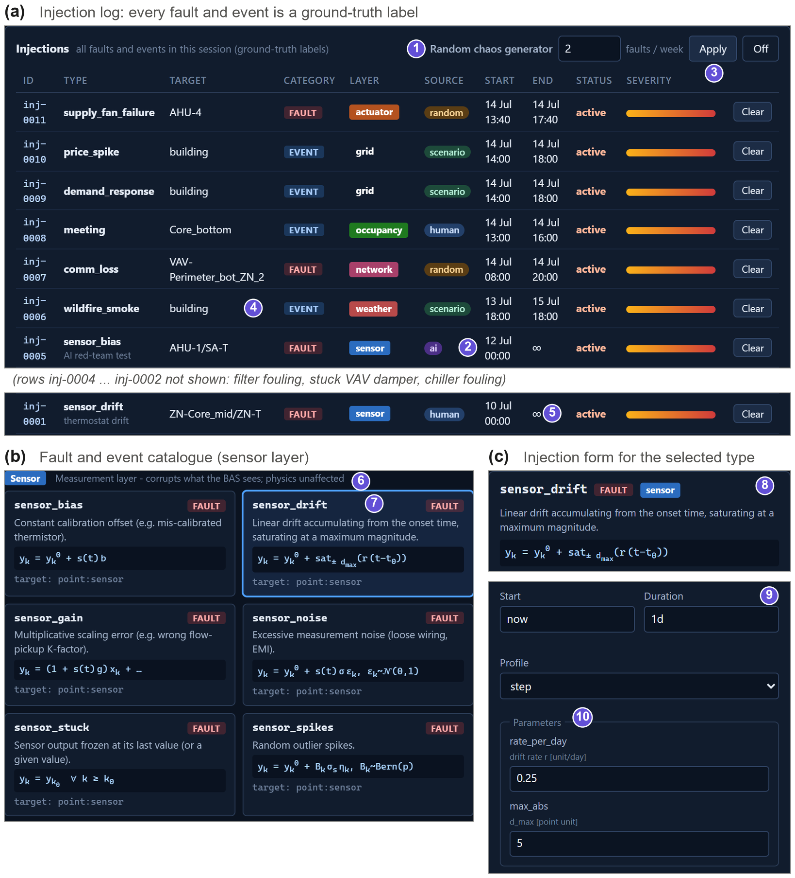
Figure 11: Fault and event injection console. (a) Injection log: humans, scenarios, the random generator (1) and AI agents (2) inject from the same catalogue, and every injection is logged with type, target, onset, end and severity profile (3) as a ground-truth label; events such as wildfire smoke are distinguished from faults (4). (b) Catalogue of the sensor layer with the defining equation of each type (6, 7). (c) Injection form generated from the parameter specification of the selected type (8–10).
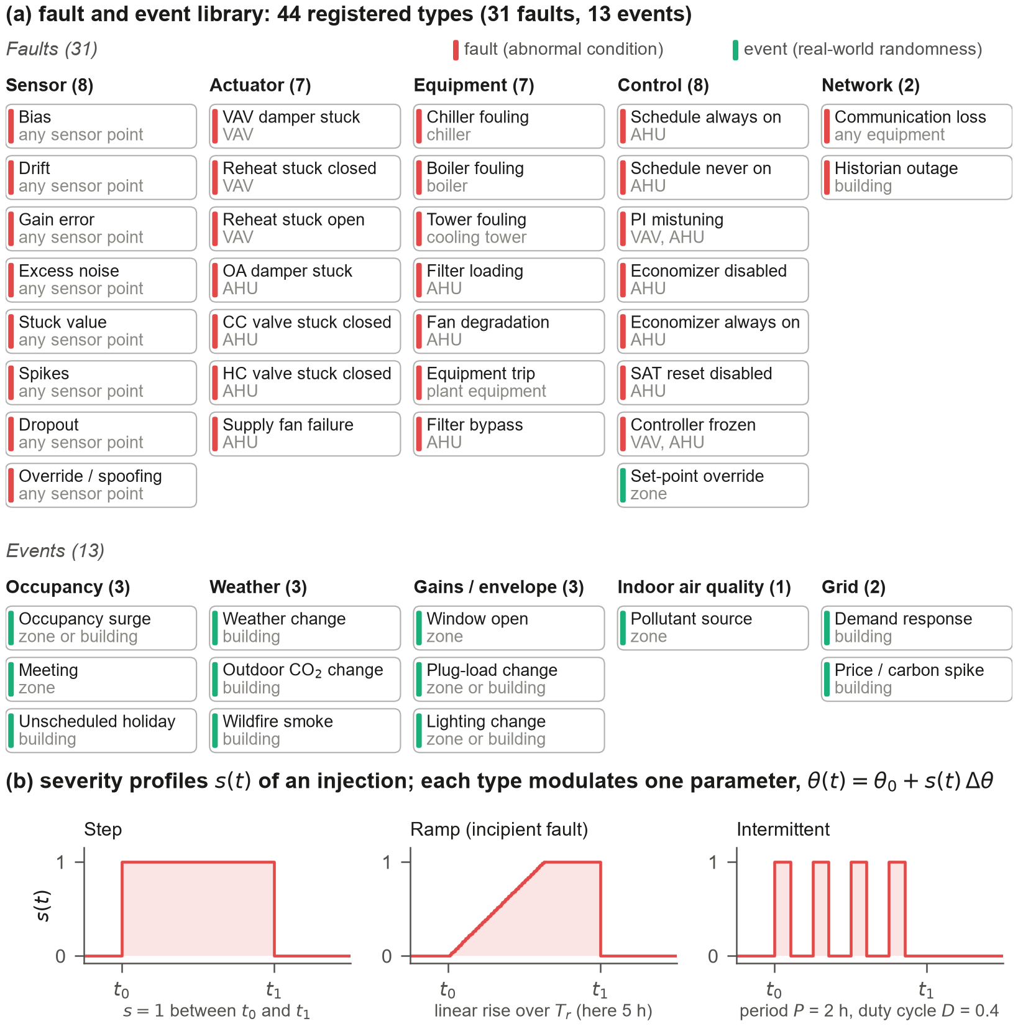
Figure 12: (a) Fault and event library: 44 registered injection types, 31 faults on five layers and 13 events, each with its target type. Every type has a defining equation and typed parameters (listed in the online fault catalog), and every injection is labelled with its source (human, AI, scenario, random). (b) Severity profiles $s(t)$ of an injection: step, ramp over $T_{r}$ (incipient faults) and intermittent with period $P$ and duty cycle $D$.

3.9 BAS control program
The BAS control program acts on present values only and comprises: occupancy scheduling and night-cycle operation; for each VAV box, cooling and heating PI loops on the zone temperature with air-flow set point between the minimum and maximum flow (optional dual maximum); for each AHU, supply fan start/stop, supply-air temperature set point, duct static pressure set point and an economizer with differential dry-bulb high limit, whose outdoor-air fraction combines a mixing-equation feed-forward on observed return and outdoor temperatures with a PI trim on the mixed-air temperature and a minimum outdoor-air limit computed from the sum of box air-flow set points; for the plant, chilled, hot and condenser water supply temperature set points. PI controllers are discrete with anti-windup and are tuned for the 5-min sampling interval. Two profiles are provided: baseline, which reproduces the native controls of the source model (including its schedules) and is used for verification, and g36, which implements trim-and-respond resets of supply-air temperature, duct static pressure and chilled-water temperature and outdoor-air reset of hot-water temperature inspired by ASHRAE Guideline 36 [39]. Any software point can be overridden through a BACnet-like 16-level priority array (operator default priority 8, AI agents 10, BAS program 16). A rule-based alarm engine raises alarms from observed values with on-delays, so that sensor faults can cause false alarms or mask real ones.

3.10 Labels and data products
A run produces synchronised tables of observed values (the BAS trend log with gaps), truth, commands and per-sample label bit masks (missing, stuck, spike, sensor fault active, communication loss, false binary reading, spoofed), a long table of the severity of every active injection at every sample, the full injection definitions, sensor installation parameters, alarm history and metadata (scenario, seed, realism, control configuration, EnergyPlus version). The exact sensor error of every sample is $y_{k}-x_{k}$. Fig. 13 shows these products for the 12-week training run of Experiment 4. The random fault generator placed 32 injections of nine types on the four AHUs (a); the label masks (b) mark every affected sample of every point, next to the background imperfections that are present without any fault (isolated missing samples, spikes, false PIR readings); and the trend of a faulty sensor can be laid over its truth with the labelled interval (c, d). A drifting mixed-air sensor departs slowly from the truth, which makes it hard to detect, whereas a stuck supply-air sensor is obvious once the true temperature moves.
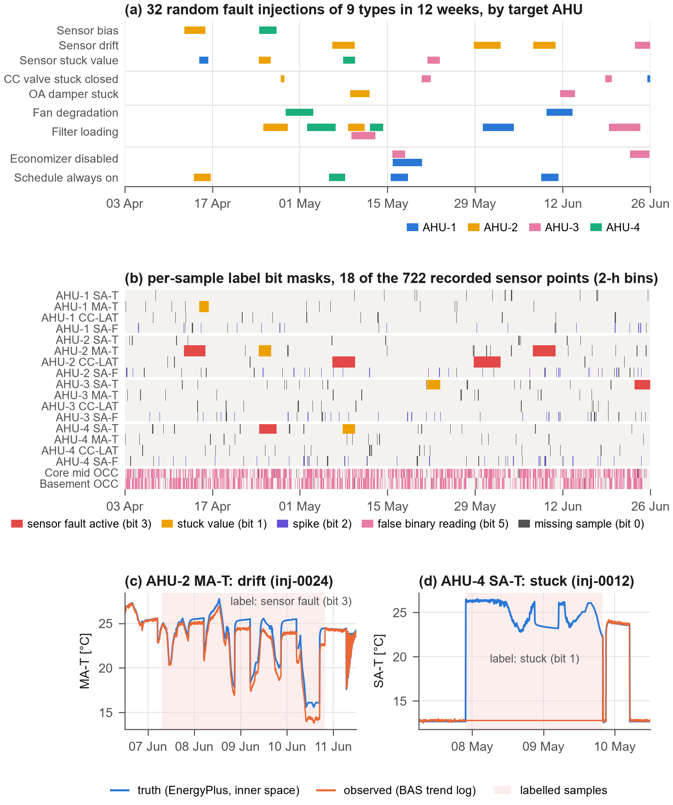
Figure 13: Labelled data from a 12-week run with random faults (training set of Experiment 4). (a) The 32 fault injections, by type and target AHU; (b) per-sample label bit masks of 18 of the recorded sensor points (2-h bins, highest-priority bit shown); (c) drift of the AHU-2 mixed-air temperature sensor and (d) stuck AHU-4 supply-air temperature sensor: observed values and EnergyPlus truth with the labelled samples shaded.

3.11 Interfaces for humans and AI
The web GUI (Figs. 15 and 16) mimics a commercial BAS front end with building overview, AHU, VAV and plant graphics, zone indoor-environment pages with a heat-map, a weather/forecast/grid/energy page, trends, alarms, a point explorer with priority overrides and an injection console generated from the fault catalog. A global switch reveals the inner space (EnergyPlus truth) next to every observed value and highlights discrepancies. The screenshots were taken during a staged session on a Friday afternoon in July in which an operator and an AI agent had injected eleven faults and events (a thermostat drift, a supply-air sensor bias, a stuck damper, fouling, a fan trip, wildfire smoke and a demand-response request among them). The operator sees what a real operator would see—a busy alarm banner, plausible zone temperatures, a demand-response request—and only the truth layer reveals that the core zones of ten floors are overcooled by almost 4 K (Fig. 15, callout 8) and that the AHU-1 supply-air sensor reads 2.7 K high (callout 10). The alarm server (Fig. 16) shows the other side of the same coin: faults with an observable symptom raise alarms, the drifting thermostat does not. The same functions are available through a REST/WebSocket API with OpenAPI documentation, a dependency-free Python client, an MCP server exposing BAS tools (read points and trends, write set points, inspect the fault catalog, inject and clear faults, control the clock) to LLM agents [35], and an in-process Gymnasium environment [36] whose agent writes set points at priority 10 and observes BAS values, with rewards computed from the truth. Fig. 14 shows the five ways in with real snippets from the repository: a drift fault can be declared in a scenario file, posted to the REST API or chosen by an LLM agent through MCP tools, a learning agent writes set points through Gymnasium, and an operator acts in the GUI. All writes meet in one priority array, so that an operator at priority 8 always overrides an AI agent at priority 10, which in turn overrides the BAS program.
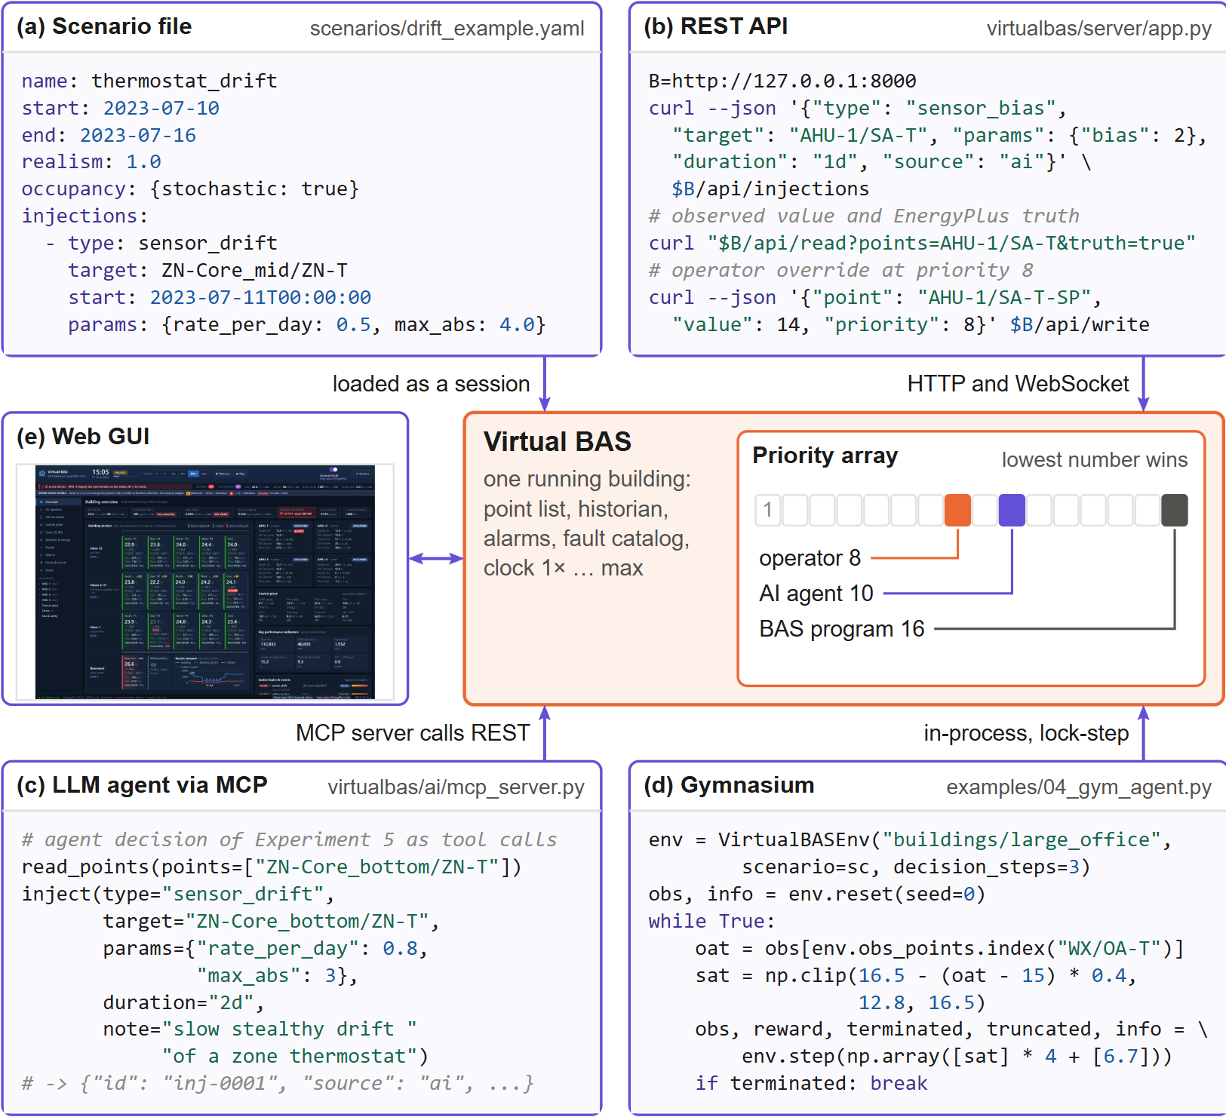
Figure 14: One building, five ways in. (a) Scenario file, (b) REST API, (c) an LLM agent through the MCP server (the first decision of the Experiment 5 agent expressed as MCP tool calls), (d) a Gymnasium control loop (abridged from examples/04_gym_agent.py) and (e) the web GUI all act on the same running emulator. Writes from any interface enter a BACnet-like priority array in which the lowest number wins (operator 8, AI agents 10, BAS program 16).
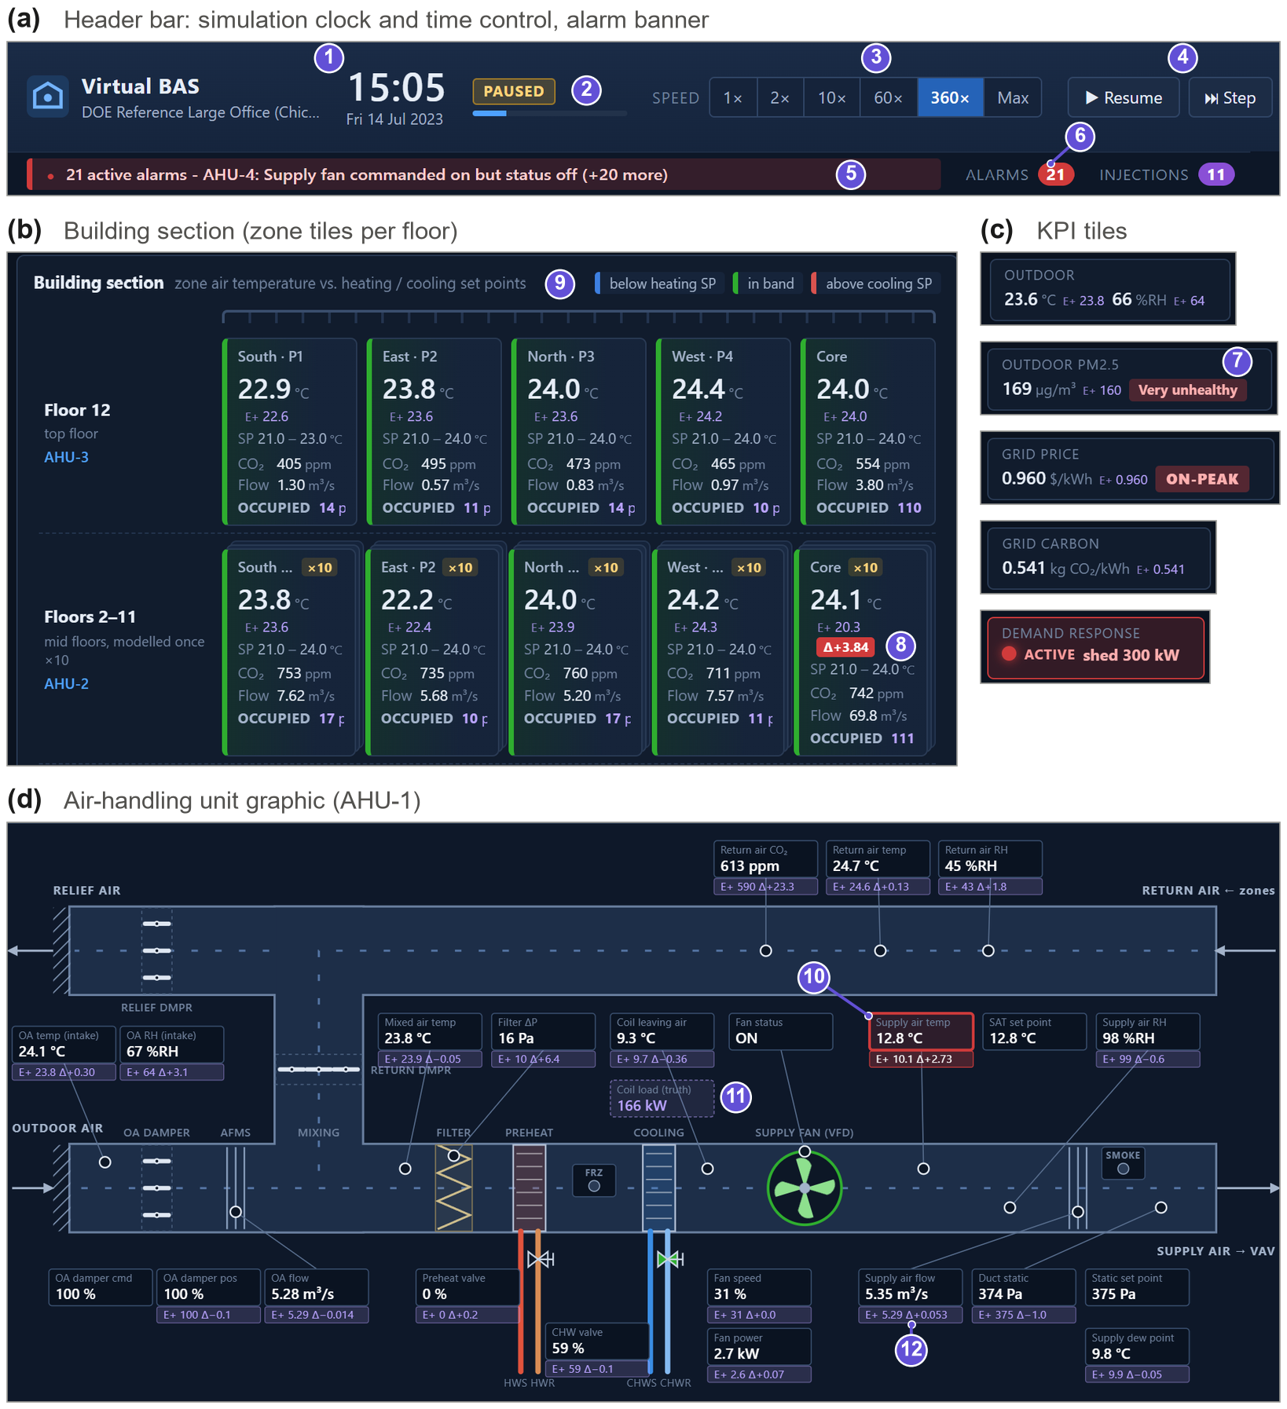
Figure 15: The Virtual BAS operator workstation, with the ground-truth layer switched on. (a) Header with the simulation clock and time control (1–4) and the alarm banner and counters (5, 6); (b) building section with one tile per zone and floor; (c) KPI tiles for outdoor air, outdoor PM2.5, tariff, grid carbon and demand response; (d) AHU graphic with equipment-level points. Every observed value carries its EnergyPlus truth (E+) and a discrepancy badge when the two disagree: the drifting Core_mid thermostat reads 24.1 $​^{∘}$C while the zone is at 20.3 $​^{∘}$C (8), and an AI-injected +2.5 K supply-air sensor bias is invisible to the controller but visible against the truth (10). Truth-only quantities have dashed boxes (11).
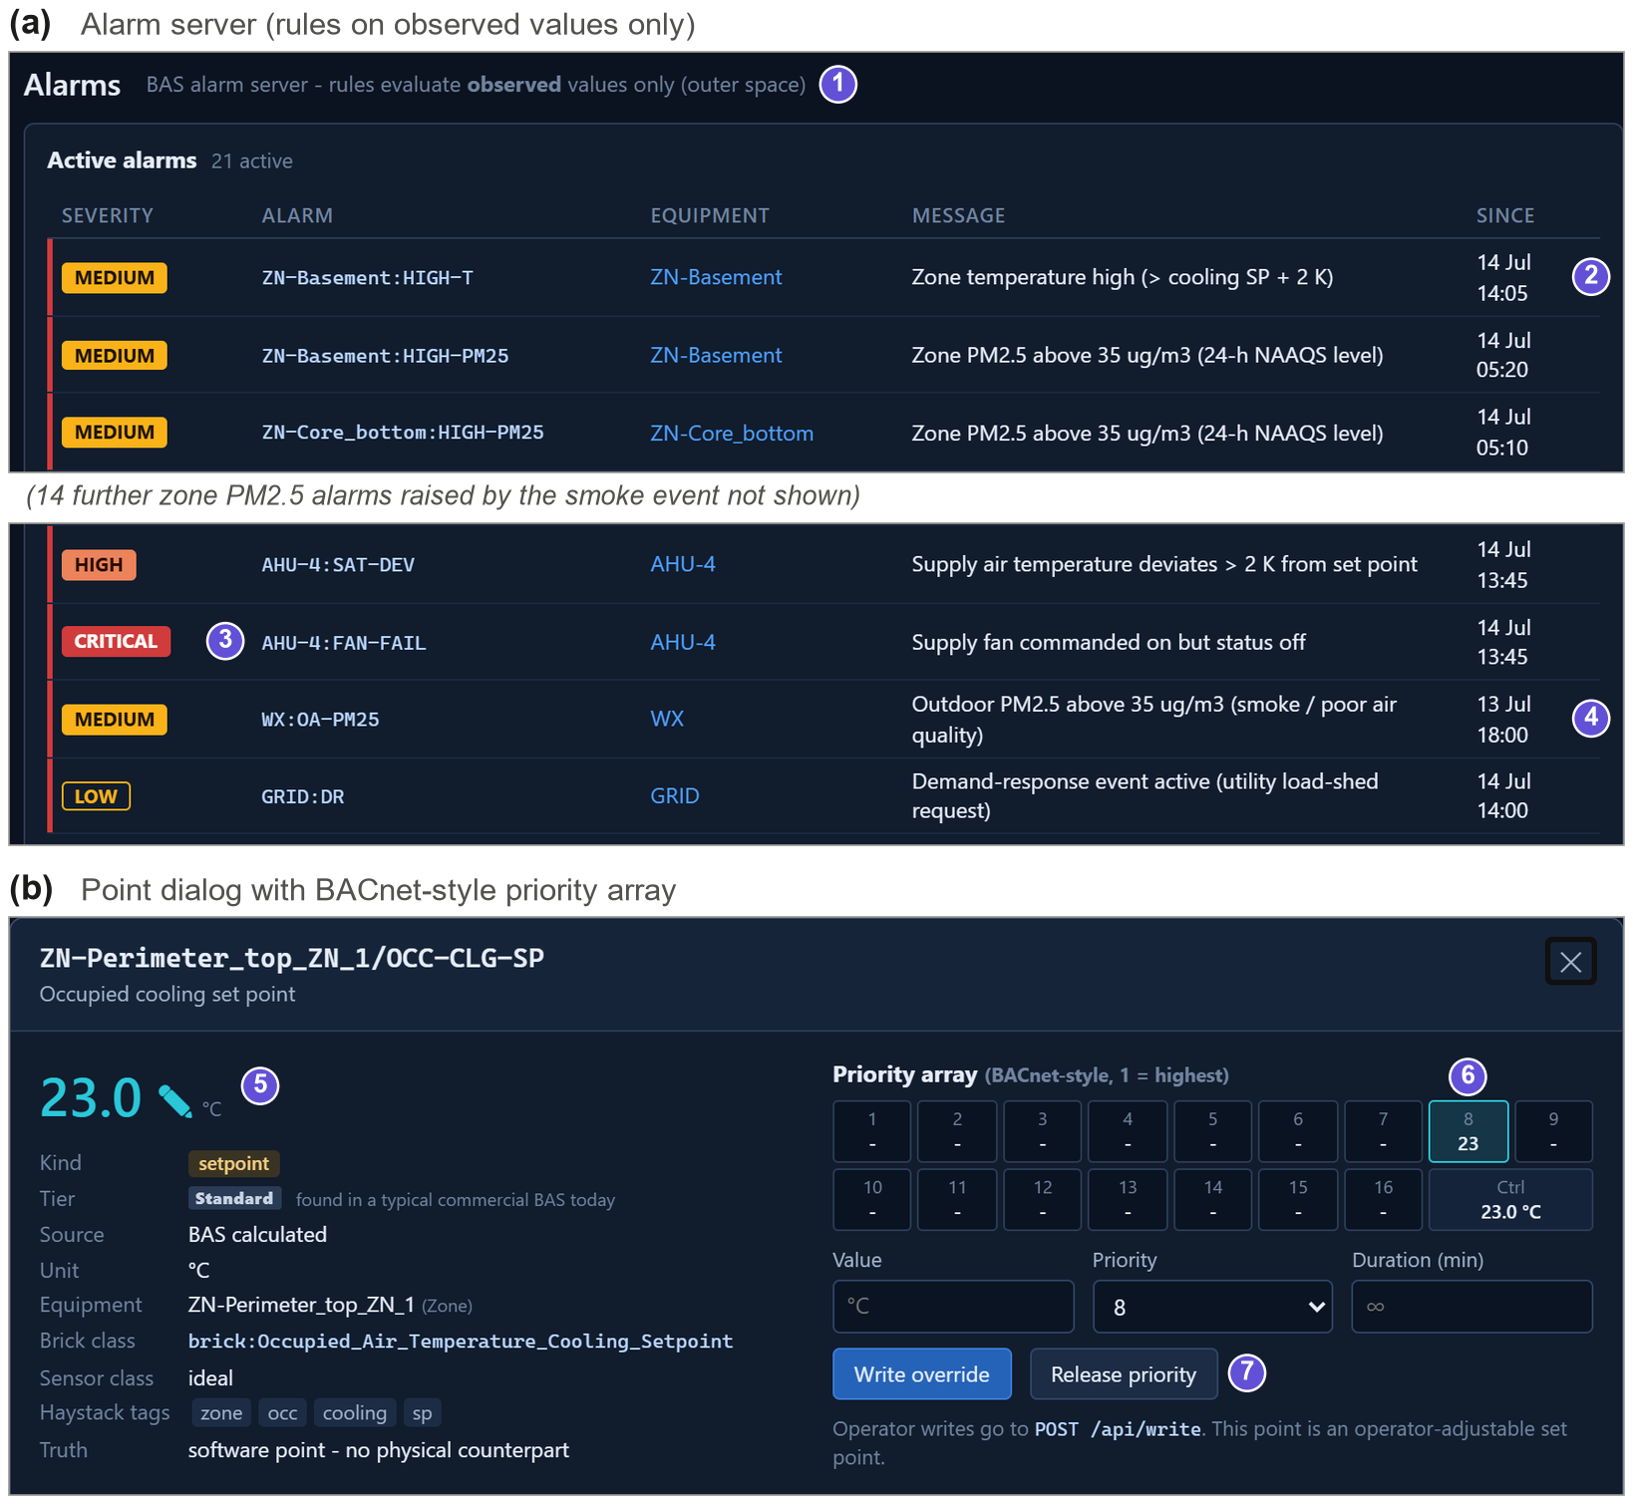
Figure 16: Alarm server and operator override. (a) Alarm rules evaluate observed values only (1), so the injected AHU-4 fan trip raises a critical alarm (3) and a consequential high zone temperature in the basement (2), and the smoke episode raises an outdoor-air-quality alarm (4), whereas the drifting thermostat raises none. (b) Point dialog of a software point with its BACnet-like 16-level priority array: an operator write of 23 $​^{∘}$C at priority 8 is active (6) and can be released (7).

4 Case study
The DOE commercial reference large office (new construction, ASHRAE 90.1-2004, Chicago) [37] distributed with EnergyPlus 23.2 is used. The 12-storey, 46320 m$​^{2}$ building is modelled with 19 zones (basement, ground, a middle floor representing ten floors through a zone multiplier, and top floor, each with four perimeter and one core zone, plus plenums), four VAV air handling units with economizers, chilled- and hot-water coils and variable-speed fans, 16 VAV boxes with hot-water reheat, two water-cooled chillers, a cooling tower, a gas boiler and three pumps. BAS-ization with a 5-min sampling interval yields 1207 points on 54 pieces of equipment (722 sensor and meter points, 325 software points and 160 ground-truth-only points); 508 points are in the standard tier, 244 advanced and 295 next-generation, and 269 take their truth from outer-space or surrogate models. The model has 28 command schedules and 4 physical fault hooks. The Chicago TMY3 weather file is used and all runs use the calendar year 2023. Experiments were run on a Windows 11 laptop with EnergyPlus 23.2 and Python 3.12. Fig. 17 shows the model and the HVAC hierarchy that BAS-ization discovered without any building-specific input: four plant loops feed four AHUs, each AHU serves the VAV boxes of one floor, and every box serves one zone.
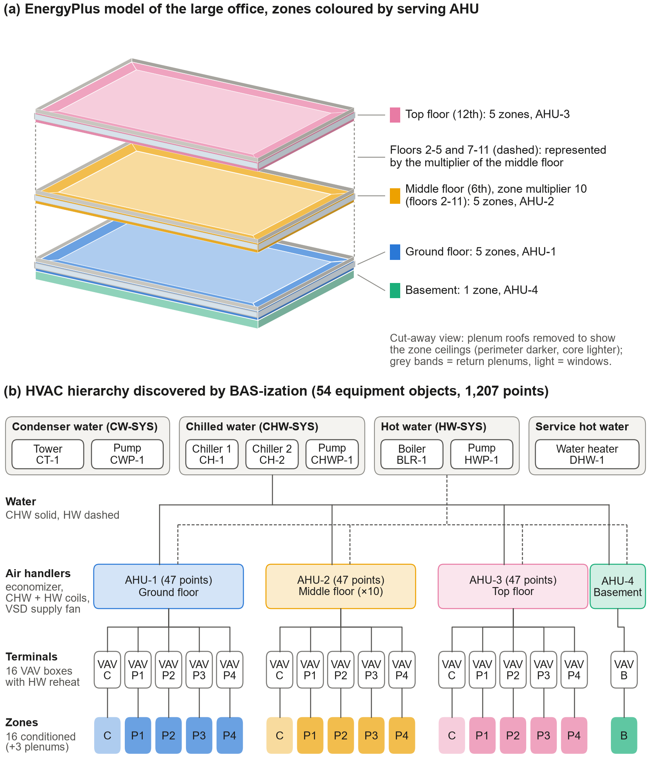
Figure 17: Case-study building. (a) EnergyPlus geometry of the DOE reference large office (cut-away view, plenum roofs removed), zones coloured by the AHU that serves them; the middle floor is modelled once with zone multiplier 10 and represents floors 2–11. (b) HVAC hierarchy discovered automatically by BAS-ization: condenser, chilled-water, hot-water and service-hot-water loops, four VAV AHUs, 16 VAV terminals with hot-water reheat and 16 conditioned zones (C = core, P1–P4 = perimeter, B = basement).

5 Experiments and results

5.1 Experiment 1: verification against native EnergyPlus
The emulator must not distort the physics. A full year was simulated (i) natively in EnergyPlus with the original controls and (ii) with Virtual BAS using ideal sensors (realism 0), deterministic occupancy and the baseline control profile, with identical time step. Table 3 and Fig. 18 compare hourly results. Annual whole-building electricity agrees within 0.5% (hourly CV(RMSE) 2.8%), cooling electricity within 1.3% and fan electricity within 0.2%; natural gas is 5.2% higher. The zone temperatures of the 16 zones differ by 0.03 K on average (MAE of hourly means). Lighting and plug loads are identical by construction. Whole-building electricity and gas both satisfy the ASHRAE Guideline 14 hourly calibration criteria (NMBE $±$10%, CV(RMSE) 30%) [46]; pump energy shows larger deviations. These residual differences are expected and have a clear origin: the native model uses ideal controllers solved within EnergyPlus’ HVAC iterations, whereas the BAS controllers are sampled-data controllers acting every 5 min on values of the previous sample. The largest differences occur at morning start-up, when the economizer and the preheat coil interact during the first samples, and in pump energy, which reacts to short chilled-water demand events. Simulating a year took 300 s with Virtual BAS (105,120 BAS samples of 722 sensor points, about 351 samples per second) versus 35 s for the native batch simulation.
Table 3: Experiment 1: annual energy of native EnergyPlus and Virtual BAS (ideal sensors, baseline profile).
End use | Native [MWh] | Virtual BAS [MWh] | Diff. [%] | CV(RMSE)$​_{h}$ [%]
Electricity, total | 5,729 | 5,756 | +0.5 | 2.8
Natural gas, total | 1,580 | 1,663 | +5.2 | 15.0
Cooling (chillers) | 509 | 502 | -1.3 | 13.9
Fans | 178 | 178 | +0.2 | 5.8
Pumps | 258 | 295 | +14.1 | 44.4
Heat rejection | 139 | 136 | -2.3 | 20.7
Heating (boiler) | 1,511 | 1,594 | +5.5 | 15.7
Interior lighting | 1,566 | 1,566 | -0.0 | 0.0
Interior equipment | 2,329 | 2,329 | +0.0 | 0.0
Zone temp. MAE / RMSE [K] | 0.029 / 0.091 (mean of 16 zones)
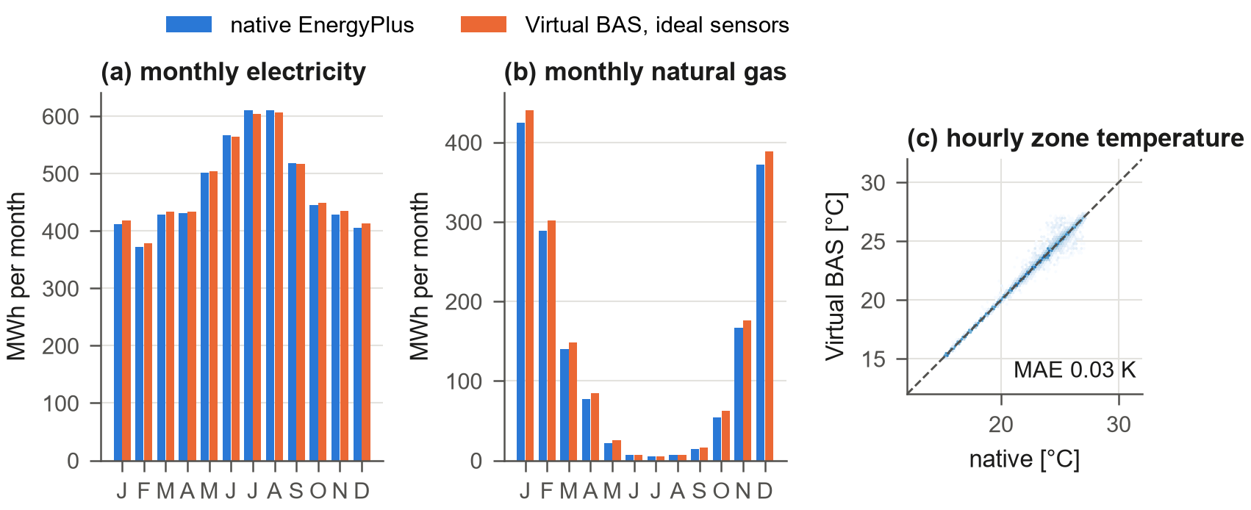
Figure 18: Experiment 1: monthly electricity and natural gas (left, centre) and hourly zone temperatures of all 16 zones (right) of native EnergyPlus and Virtual BAS with ideal sensors.

5.2 Experiment 2: inner/outer-space coupling under sensor drift
The motivating example was simulated for one summer week with realistic sensors and stochastic occupancy: the zone temperature sensor of the core zone of the middle floors (representing ten floors) drifts by $+0.5$ K/day from the second day, compared with a fault-free twin run with identical random streams (Fig. 19). The VAV controller keeps the observed temperature at the cooling set point throughout. The true temperature, however, decreases day by day; at the end of the week the sensor reads 2.8 K above the truth. The controller compensates the apparent overheating with more air: the mean discharge air flow during occupied hours increases by 15%, and the building’s HVAC electricity increases by 4.2%. None of this is visible to a BAS operator looking at the zone temperature trend. The run demonstrates the central mechanism of Virtual BAS: an outer-space imperfection produces a wrong control signal, the wrong signal changes the physics, and the change is labelled. Fig. 20 shows the same mechanism as an operator experiences it in the staged GUI session (a faster drift of 0.8 K/day from Monday): the VAV graphic and the terminal status report a zone at its 24 $​^{∘}$C set point, the trend of the observed temperature is flat, and only the truth overlay reveals the zone at 20.3 $​^{∘}$C and a PMV of $-1.6$ by Friday. No alarm fires, because no observed value leaves its band.
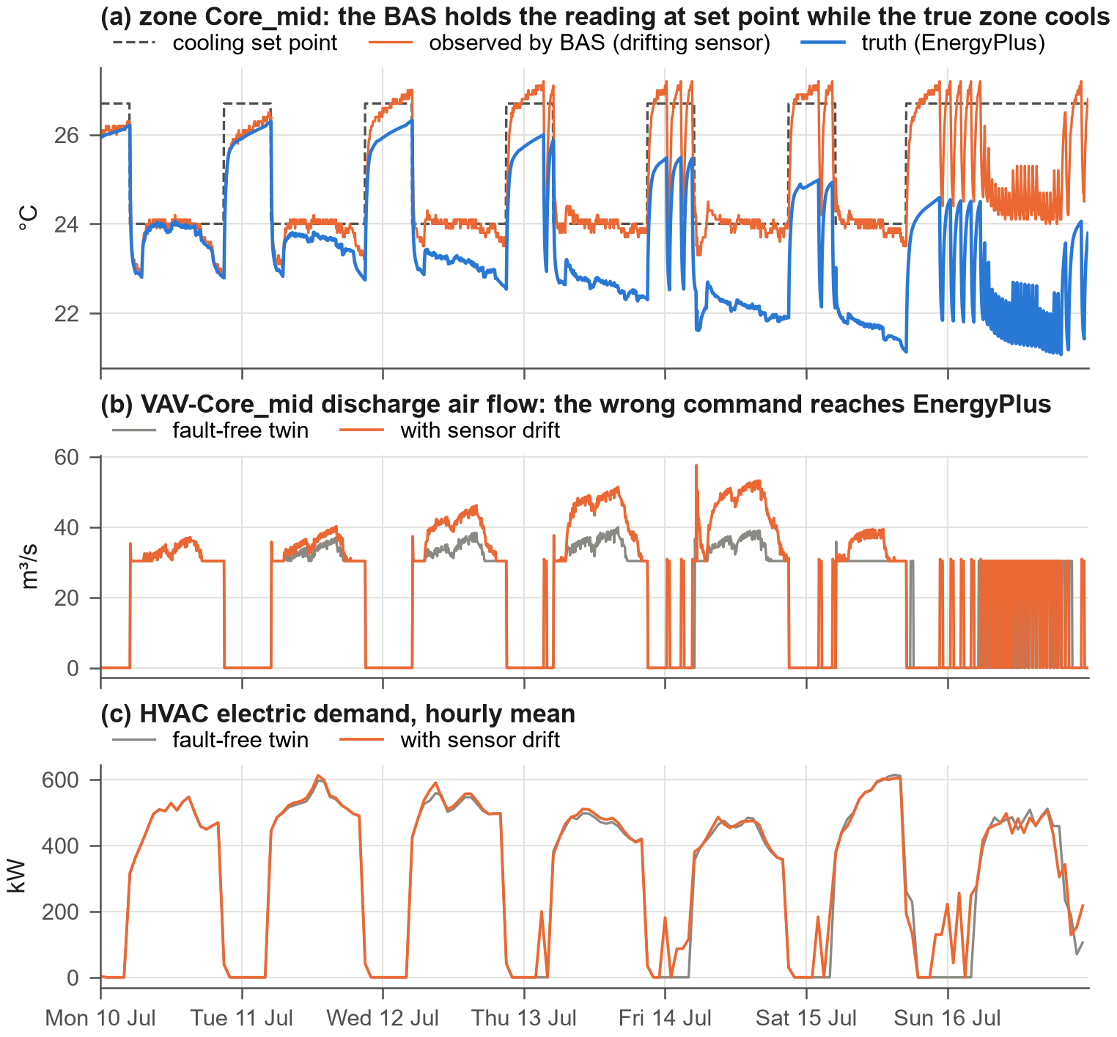
Figure 19: Experiment 2: drift of the zone temperature sensor of zone Core_mid. (a) Observed and true zone temperature; (b) discharge air flow of the VAV box with and without drift; (c) HVAC electric demand.
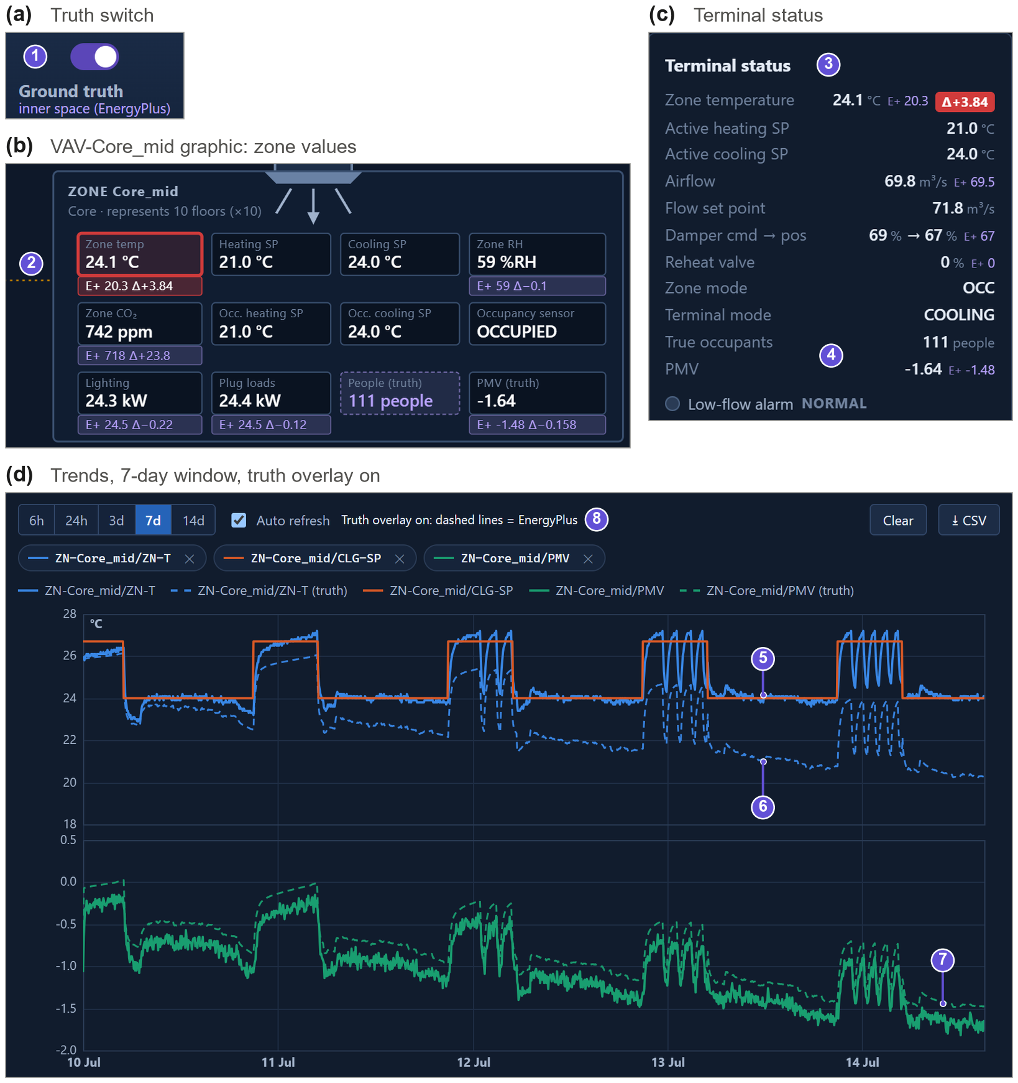
Figure 20: The thermostat drift as seen in the GUI (staged session, 0.8 K/day from Monday 00:00). (a) Ground-truth switch (1); (b) VAV-Core_mid graphic and (c) terminal status: observed 24.1 $​^{∘}$C against an EnergyPlus truth of 20.3 $​^{∘}$C (2, 3), with the truth-only occupant count and PMV (4); (d) 7-day trends: the observed temperature is held at the cooling set point (5) while the truth (dashed) falls to about 20 $​^{∘}$C (6) and PMV to about $-1.6$ (7).

5.3 Experiment 3: equipment-level fault impact matrix
Twenty-seven single-fault scenarios covering all layers were each simulated for a summer and a winter week with realistic sensors and stochastic occupancy and compared with the fault-free twin (common random numbers). Fig. 21 reports the changes in electricity, gas and discomfort (occupied K$⋅$h outside the set-point band $±0.5$ K, computed from the truth); rows are grouped by layer (sensor, actuator, equipment, control, network, events). The matrix shows physically consistent, season-dependent behaviour at equipment level. A stuck-open outdoor-air damper of the main AHU increases winter gas by 157% but has little effect in summer; a closed damper saves heating energy at the cost of ventilation. A leaking reheat valve increases summer gas consumption 16-fold relative to the fault-free week and causes 114 K$⋅$h of overheating. A stuck-closed chilled-water valve of AHU-1 produces 1210 K$⋅$h of summer discomfort but no winter effect; a stuck-closed reheat valve does the opposite (162 K$⋅$h in winter). Chiller and tower fouling raise summer electricity by 1.0% and 3.3%, boiler fouling raises winter gas by 55%, filter fouling and fan degradation raise fan energy. A trip of one of the two chillers reduces summer electricity because the remaining chiller operates at a more efficient part-load ratio, while discomfort increases at peak load—a reminder that fault impacts are not always energy penalties. A 24/7 schedule error on the main AHU increases summer electricity by 14.4%. Several faults are silent in one season (e.g. economizer and mixed-air sensor faults in summer, stuck-closed reheat valve in summer), an important property of real fault data that a dataset generator must reproduce: labels mark fault presence, while the twin comparison quantifies fault impact.
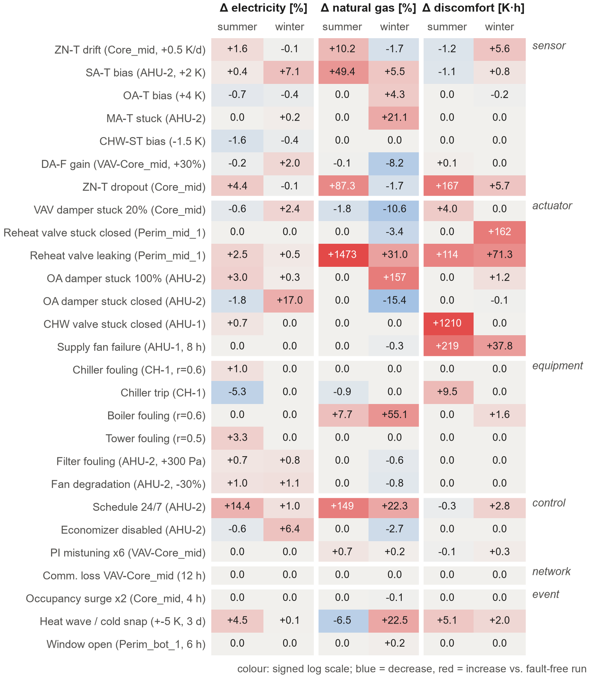
Figure 21: Experiment 3: change of electricity, natural gas and discomfort relative to the fault-free twin for 27 single-fault scenarios (one week each, summer and winter). Colour: signed logarithmic scale.

5.4 Experiment 4: labelled data generation and an FDD benchmark
Two independent datasets were generated with the random fault generator restricted to nine AHU-level fault types (sensor bias, drift and stuck on AHU temperature sensors, stuck outdoor-air damper, stuck-closed chilled-water valve, filter fouling, fan degradation, disabled economizer, schedule error) at $λ=3$ per week: a training set (April–June, Fig. 13) and a test set (July–August) with different seeds. Hourly features (means and standard deviations of 23 quantities, e.g. supply-air temperature error, mixing-equation residual, outdoor-air damper command/feedback deviation, fan power per flow, filter pressure drop) were computed from the observed trend logs only, and labels from the injection severity tables. A random forest [47, 48] trained on 8,064 AHU-hours reaches a detection macro-F1 of 0.74 and a diagnosis macro-F1 of 0.24 on 5,376 test AHU-hours (Fig. 22). The difficulty is genuine and informative: the test period lies in a different season, background sensor errors and missing data are present, and several faults are unobservable under the prevailing conditions (e.g. a disabled economizer in hot weather). The experiment demonstrates that Virtual BAS produces ML-ready, consistently labelled data with controllable difficulty, distribution shift and realistic class imbalance.
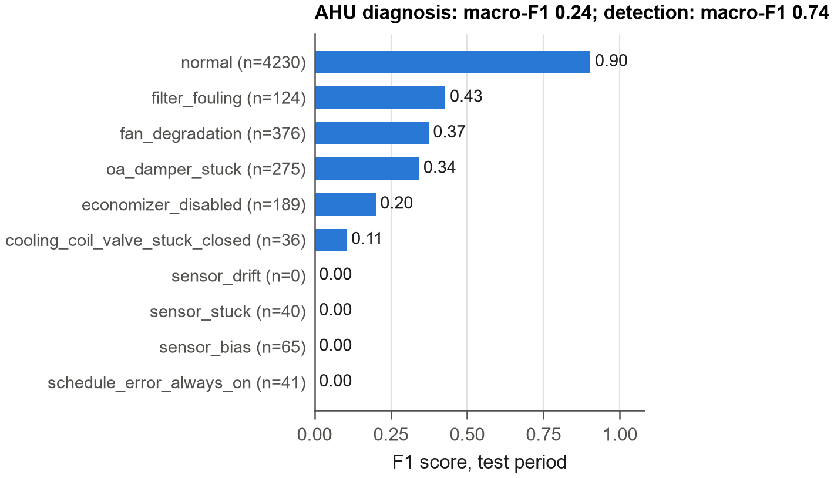
Figure 22: Experiment 4: per-class F1 score of the AHU fault diagnosis benchmark on the test period.

5.5 Experiment 5: AI agents in the loop
AI fault injection through the public API. An autonomous adversarial agent operated the building for six days through the REST API, in lock-step with the simulation (pause, 6 h steps). Every six simulated hours it read the BAS like an operator and chose an injection: forcing 100% outdoor air on the AHU with the largest fan power when the outdoor air was hot, an after-hours schedule error in the evening, and otherwise a slow drift of a zone thermostat. It injected 24 faults, all recorded with source=ai and the agent’s rationale. The same calls are exposed as MCP tools, so an LLM agent can play the same role, for example to stress-test an FDD system.
Robustness of a supervisory AI controller. A supervisory agent resetting the AHU supply-air and chilled-water set points from the observed outdoor-air temperature was evaluated through the Gymnasium interface in three outer spaces—ideal sensors, realistic sensors, and realistic sensors with a $+4$ K bias of the outdoor-air sensor—for two weeks in the shoulder season and in summer, each against the baseline BAS program in the same outer space (Fig. 23). In the shoulder season the agent reduces electricity by 5.2% with ideal sensors and 6.4% with realistic sensors, but only by 3.3% when the outdoor-air sensor reads 4 K high, because the biased reading shifts every reset decision. At the same time the warmer supply air increases preheat and reheat gas use by 21 MWh in two weeks (realistic sensors), so that site energy changes by +2.5%; in summer the electricity saving is small (0.3%). An evaluation restricted to electricity and to ideal sensors would therefore have overstated the value of this policy twice. Such trade-offs and their sensitivity to measurement errors must be understood before an AI controller is deployed, and they cannot be studied in an idealised environment.
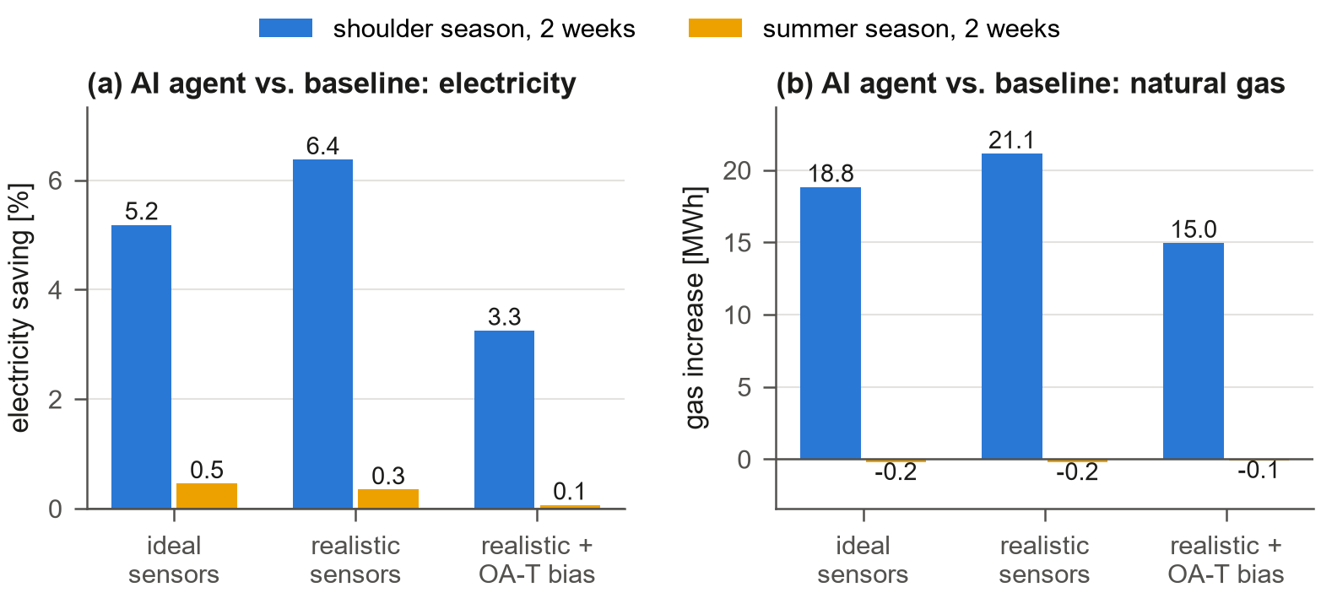
Figure 23: Experiment 5: electricity saving (left) and gas increase (right) of a supervisory AI controller relative to the baseline BAS program in three outer spaces (ideal sensors, realistic sensors, realistic sensors with a $+4$ K outdoor-air sensor bias).

5.6 Experiment 6: indoor environment under wildfire smoke
A summer week with a 30-h wildfire-smoke episode (outdoor PM2.5 up to 133 $μ$g/m$​^{3}$) was simulated with the reference MERV 8 filters, with MERV 13 filters, with a filter-bypass fault (60% bypass, no pressure-drop symptom) and with an IEQ-aware sequence that locks the economizers out while the outdoor PM2.5 exceeds 35 $μ$g/m$​^{3}$ (Fig. 24a). Because the economizers bring up to 100% outdoor air in this season, the mean indoor concentration peaks at 93 $μ$g/m$​^{3}$ with MERV 8, 111 $μ$g/m$​^{3}$ with the bypass fault, 66 $μ$g/m$​^{3}$ with the economizer lock-out and 45 $μ$g/m$​^{3}$ with MERV 13; occupied zone-hours above 35 $μ$g/m$​^{3}$ are 362, 367, 346 and 104. None of this is visible in the standard tier: a typical BAS of today has no particle sensor, the bypass fault has no pressure-drop symptom, and the lock-out decision requires the next-generation outdoor PM2.5 point. Figs. 24b–e show one day of the other environment points of a perimeter zone: illuminance with its daylight share and the photosensor reading, PMV with the sparse mean votes of the zone’s occupants, TVOC flushed by the morning ventilation and its noisy metal-oxide reading, and the sound level of terminal noise and speech.
Because every zone has its own mass balance, the episode can also be resolved in space (Fig. 25). During the day, with the economizers at 100% outdoor air (instant A), the filter is the only barrier: all zones are near the zone mean of 93 $μ$g/m$​^{3}$ with MERV 8 and 38 $μ$g/m$​^{3}$ with MERV 13. At night, with the AHUs off (instant B), the pattern inverts: infiltration carries smoke into the perimeter zones (54–59 $μ$g/m$​^{3}$) regardless of the filter, while the core zones stay cleaner, so that a filter upgrade alone does not protect perimeter spaces during unoccupied hours. Such spatial patterns, and the zone-level sensors needed to see them, are exactly what the next-generation tier lets an analyst or an AI agent study. For the operator, the episode appears on the site page of the GUI (Fig. 26) as an outdoor-air-quality alert with advice, next to the tariff, grid carbon intensity, an active demand-response request and the 48-h weather forecast.
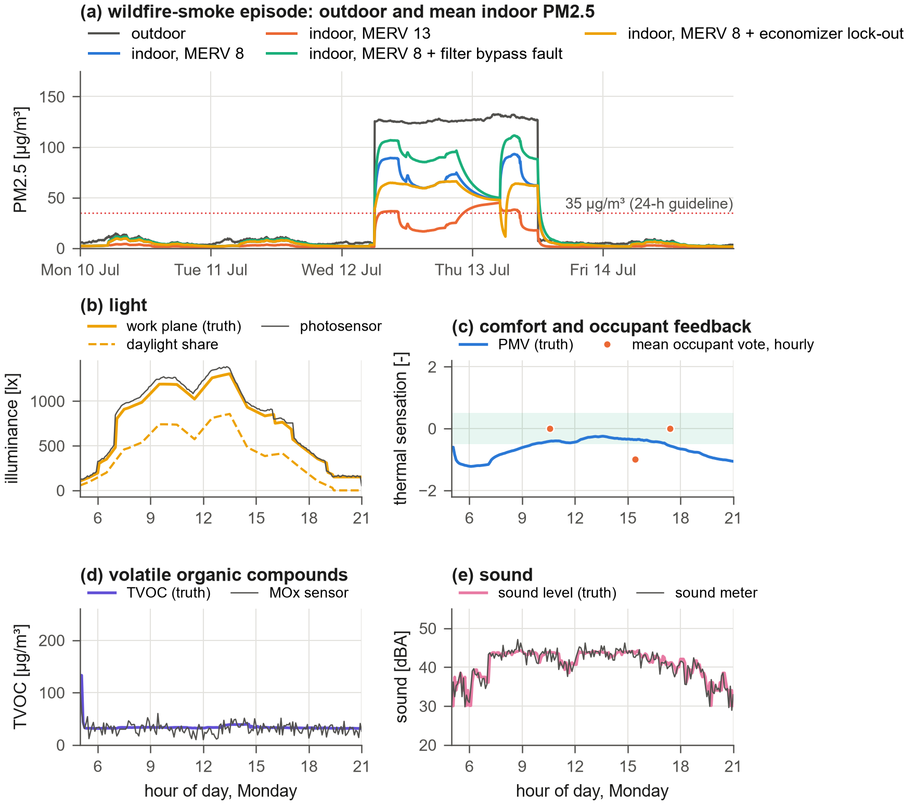
Figure 24: Experiment 6: (a) outdoor and mean indoor PM2.5 during a wildfire-smoke episode for four filter/control situations; (b)–(e) one summer day of illuminance, comfort and occupant feedback, TVOC and sound in a perimeter zone (truth and sensor readings).
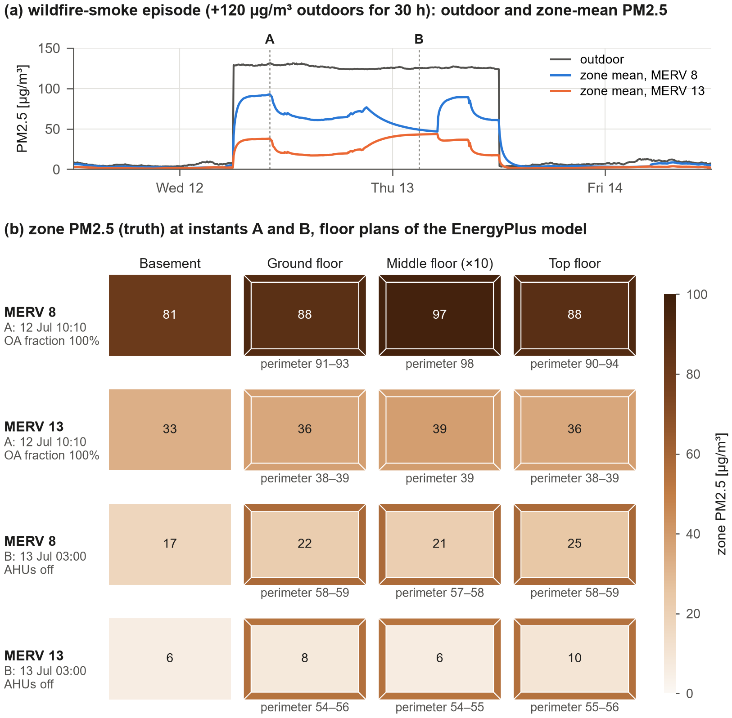
Figure 25: Experiment 6 in space. (a) Outdoor and zone-mean PM2.5 during the 30-h smoke episode with MERV 8 and MERV 13 filters; (b) zone PM2.5 (truth) on the floor plans of the EnergyPlus model at instant A (economizers at 100% outdoor air) and instant B (night, AHUs off); perimeter values below each plan.
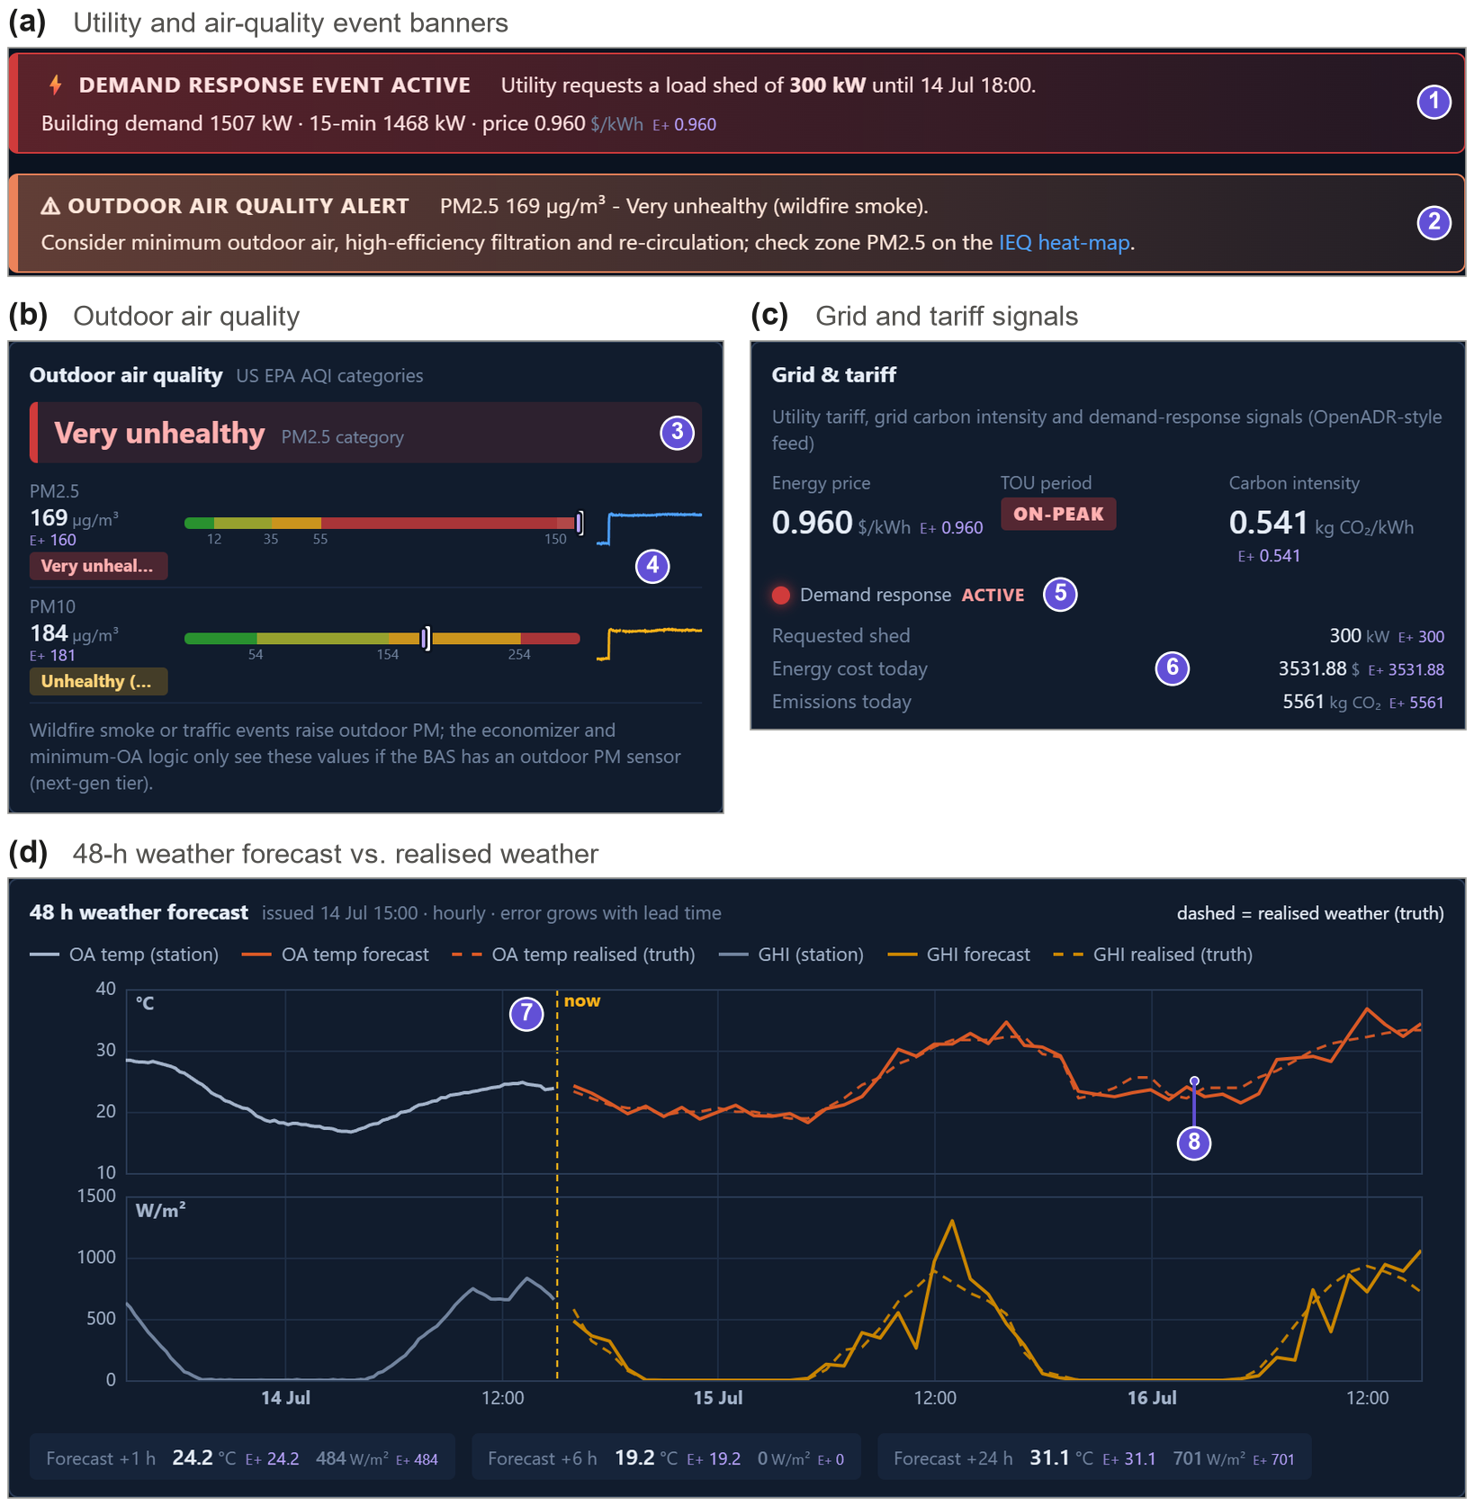
Figure 26: Site, utility and forecast page of the GUI during the staged smoke episode. (a) Event banners: a demand-response request of 300 kW (1) and an outdoor-air-quality alert with operator advice (2); (b) outdoor air quality with AQI category (3) and observed versus true PM2.5 and PM10 (4); (c) grid and tariff with the active demand-response event (5) and cost and emissions accounting (6); (d) 48-h forecast issued at the current hour (7) against the realised weather (8).

5.7 Experiment 7: time acceleration
The pacing accuracy was measured by setting target speed factors while running (Fig. 27). The achieved speed matches the target within 0.01% for factors from 10 to 3600; at maximum speed one BAS sample takes 3.3 ms, i.e. 92,000 times real time, so one simulated year runs in about 5.0 minutes. Real time (1$×$) follows from the same pacing law. The speed can be changed, paused or single-stepped at any moment from the GUI or the API, which allows the same environment to serve real-time interaction with people or deployed agents and fast training of learning agents.
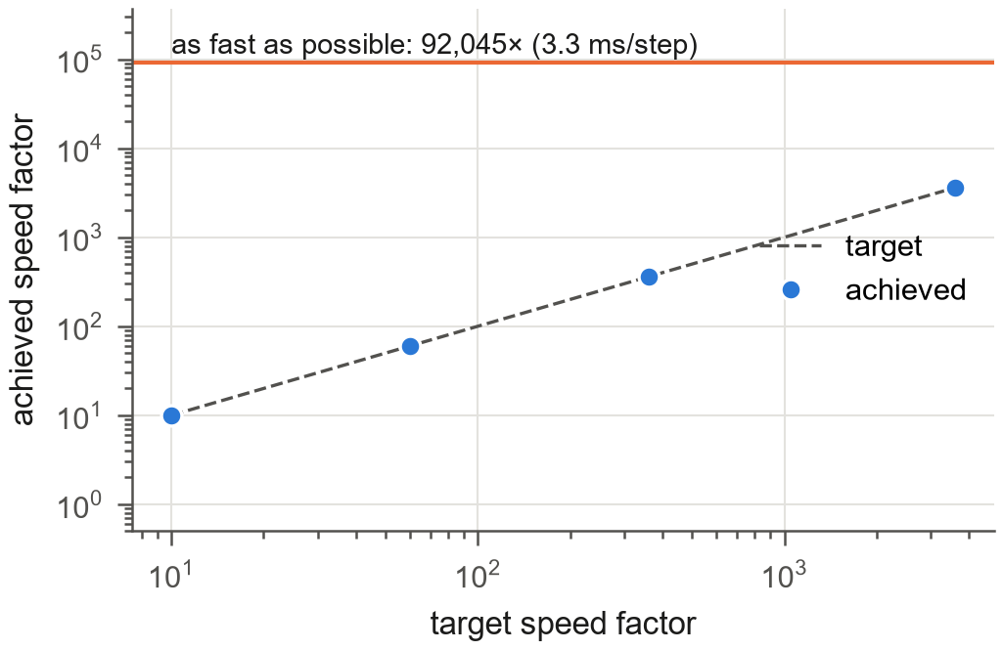
Figure 27: Experiment 7: target versus achieved speed factor and maximum throughput.

5.8 Experiment 8: generality
The BAS-ization procedure was applied without any building-specific code to five DOE reference buildings (Fig. 28). All models were converted and simulated for one week, from a single-storey small office with five packaged units to a hospital with 55 zones; the number of points grows with the number of zones and terminals, and the simulation speed decreases accordingly but remains far above real time. Multi-zone VAV systems with water-based plants (large office, hospital, secondary school) are fully BAS-controlled; the medium office (packaged VAV with DX cooling and electric reheat) and the small office (packaged single-zone units) are monitored completely and their terminals and thermostats are BAS-controlled while unsupported components keep their native local control. The hospital, with 55 zones and four 100%-outdoor-air and mixed-air AHUs, yields 3244 points on 128 pieces of equipment and runs at 60 samples per second.
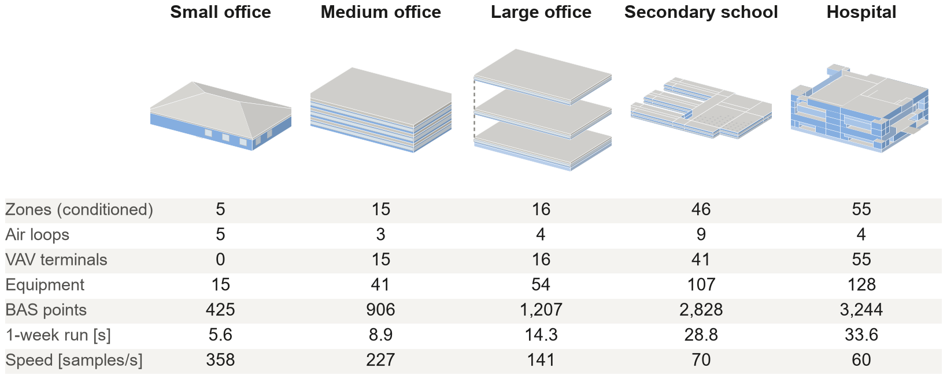
Figure 28: Experiment 8: five DOE reference buildings converted automatically (EnergyPlus geometry, not to scale; conditioned zones in blue, windows light) with key figures of the one-week runs.

6 Discussion

6.1 Potential uses and impact
A real BAS is a poor place to learn, experiment or certify: faults cannot be staged on demand, the true state is unknown, every mistake affects occupants and equipment, a year of operation takes a year, and access is restricted by owners, vendors and cyber-security policies. Virtual BAS removes each of these barriers at once—it is safe to break, labelled, repeatable through seeded scenarios, faster than real time, free and open, and it can be generated for any EnergyPlus model. Fig. 29 maps eighteen uses that follow from these properties onto four areas, and Table 4 lists them with their users, the enabling features and the evidence available in this paper. The table distinguishes uses that the experiments demonstrate from uses for which the interfaces exist but no evaluation is reported here.
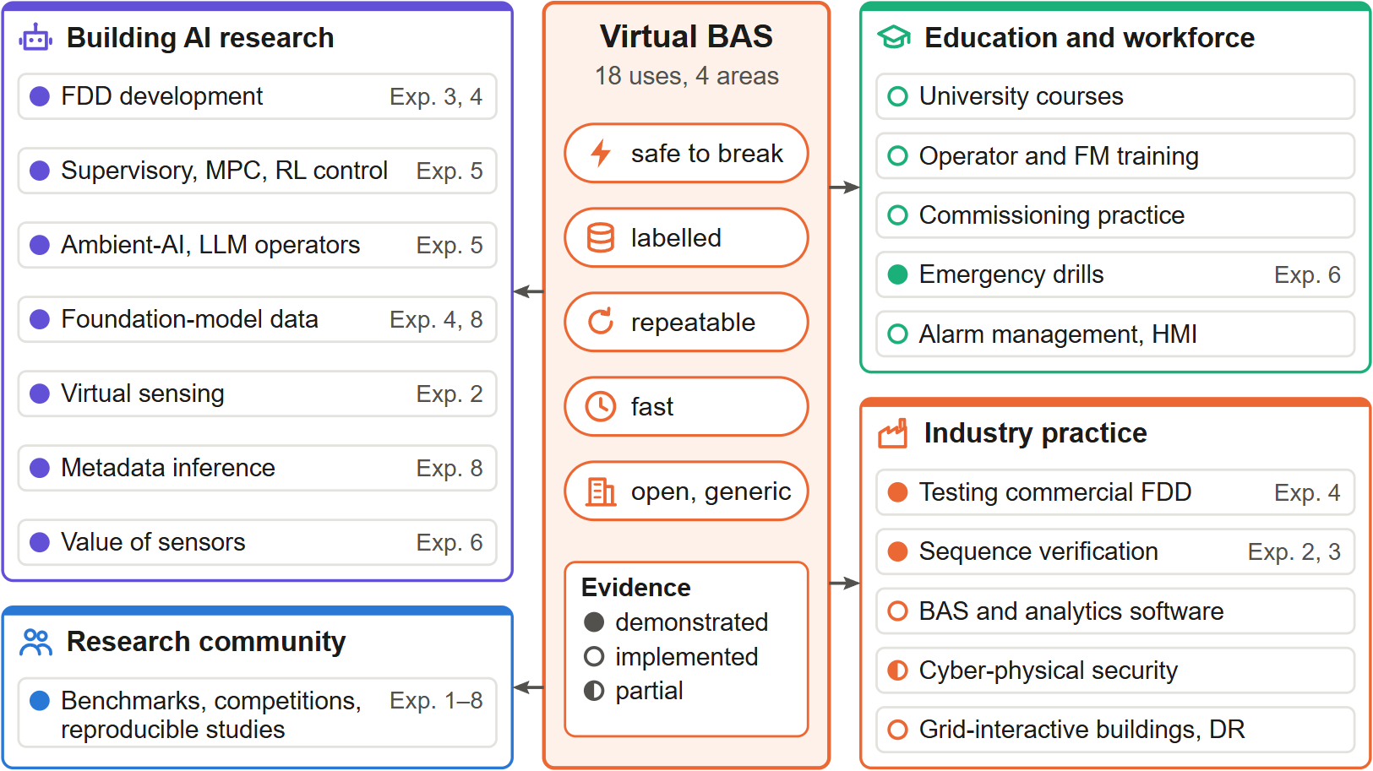
Figure 29: Eighteen uses of Virtual BAS in four areas, all following from five properties: safe to break, labelled, repeatable, fast, and open and generic. Filled dots mark uses demonstrated by the experiments of this paper (experiment numbers at right); open dots mark uses whose required functions are implemented but not evaluated here; the half-filled dot marks partial support (Table 4).
Table 4: Potential uses of Virtual BAS, with primary users in italics. Evidence: Exp. $n$ = demonstrated in Experiment $n$; interf. = all required functions are implemented but not evaluated in this paper; partial = some functions are missing (see Section 6.2).
Use (users) | What Virtual BAS provides | Evid.
Research and development of building AI
FDD development and benchmarking (FDD researchers, analytics developers) | Unlimited labelled data with controlled fault type, severity, season and sensor quality; closed-loop tests | Exp. 3, 4
Supervisory, MPC and RL control (control and RL researchers) | Gymnasium; sensor errors, missing data and faults; ideal vs. realistic outer space on the same physics | Exp. 5
Ambient-AI and LLM operators (AI researchers, BAS vendors) | MCP tools, overrides and alarms at any speed; ground truth for scoring; agents as operators and adversaries | Exp. 5
Foundation models (machine-learning researchers) | Diverse, labelled, multivariate BAS time series for any EnergyPlus model [49] | Exp. 4, 8
Virtual sensing and sensor recalibration (researchers) | Observed and true values side by side; defined bias, drift, lag and data-loss models | Exp. 2
Metadata inference, portable apps (researchers, integrators) | Haystack/Brick point lists with known metadata for converted buildings [50] | Exp. 8
Value of information, sensor design (sensor makers, standard writers) | Standard, advanced and next-generation tiers; one scenario seen through different instrumentation | Exp. 6
Education and workforce development
University courses (instructors, students) | BAS-like GUI; equipment that can be broken safely; truth switch; open scenarios; a season in one lab session | interf.
Operator and facility-manager training (owners, utilities, training programmes) | Drills with hidden or random faults; alarms, trends and overrides as in a real BAS; labels as answer key | interf.
Commissioning practice (commissioning agents) | Functional tests of sequences, staged faults, trend review against known causes | interf.
Emergency and resilience drills (facility managers) | Wildfire smoke, heat waves, cold snaps, equipment trips, demand response at run time | Exp. 6
Alarm management, HMI research (human-factors researchers) | Reproducible alarm floods and faults for user studies under identical conditions [51] | interf.
Industry practice
Testing commercial FDD and analytics (owners, efficiency programmes) | Blind test buildings with known faults and severities; scoring against labels | Exp. 4
Sequence verification, virtual commissioning (designers, contractors) | G36-style sequences in closed loop and under sensor faults before site work [52] | Exp. 2, 3
BAS and analytics software (vendors, start-ups) | A mock building behind REST, WebSocket and MCP for integration tests and demonstrations | interf.
Cyber-physical security (security researchers) | Spoofed readings, malicious overrides, controller and historian outages, physical impact [53] | partial
Grid-interactive buildings (utilities, aggregators) | Tariff, carbon intensity, demand-response events, demand meters [54] | interf.
Research community
Benchmarks, competitions, reproducibility (all) | Seeded scenarios, open building models, common KPIs, public code | Exp. 1–8
Research and development of building AI. Virtual BAS is first a proving ground for building AI. FDD developers obtain unlimited labelled data with controllable fault rates, severities, seasons and sensor quality and can test algorithms in closed loop (Experiments 3 and 4). Control and RL researchers can evaluate policies under partial observability, sensor errors, missing data and equipment faults, and quantify robustness by switching the outer space while keeping the inner space fixed (Experiment 5). Ambient-AI and LLM agents can be connected through MCP and evaluated on operational tasks (diagnosing complaints, finding faults, writing safe overrides) with exact ground truth; they can also act as adversaries that generate challenging scenarios. Because any EnergyPlus model can be converted, the emulator can also produce the large and diverse corpora of BAS-level, multivariate, labelled time series that foundation models for building operation will need; existing synthetic corpora for pre-training cover whole-building loads only [49]. The point tiers support sensor-placement and value-of-information studies: the same scenario can be observed through the instrumentation of a typical BAS and through next-generation sensing, and the benefit of, e.g., coil energy meters, people counters or particle monitors for a given task can be measured against ground truth (Experiment 6).
Education and workforce development. Students rarely get write access to a real BAS, and when they do they cannot break it. With Virtual BAS a course on HVAC systems, controls or building data science can let every student operate the same building, change set points and sequences, inject a stuck damper or a drifting sensor and see both what the BAS shows and what really happens; time acceleration fits a season of operation into a laboratory session. For operators, facility managers and technicians the same features become troubleshooting drills. The GUI hides the ground truth by default, an instructor injects faults from the console or lets the random fault generator choose them, the trainee works only with graphics, trends, alarms and overrides, and the label record then serves as the answer key for scoring. This brings to building operation the simulator-based training that is standard in aviation and nuclear power [26] and has so far been limited to prototypes in buildings [28, 29]. Commissioning agents can rehearse functional tests, and facility managers can practise responses to wildfire smoke, heat waves, equipment trips and demand-response events. Reproducible alarm floods also make it possible to study alarm management and operator interfaces with human participants [51].
Industry practice. Owners and efficiency programmes that procure FDD or analytics services currently have no neutral way to compare products; a blind Virtual BAS building with known faults gives such a test, scored against the labels (Experiment 4). Designers and control contractors can exercise sequences in closed loop, including their behaviour under sensor faults, before the site work, complementing formal specification and verification workflows [52]. BAS and analytics vendors obtain a mock building for continuous integration, demonstrations and training of their own staff. Security researchers can emulate spoofed readings with sensor-layer faults, malicious commands with overrides and outages with network-layer faults, and observe the physical impact of an attack [53]. Utilities and aggregators can test demand-response and carbon-aware strategies with the tariff, grid and demand-meter points [54]. Given the savings at stake in commissioning [24] and controls [25], even a modest improvement in how people and software operate buildings has a large aggregate effect.
Research community. Seeded scenarios, open building models and common KPIs allow benchmarks and competitions in which every participant faces the same faults, sensor errors and occupants, and allow results to be reproduced exactly. This addresses a recurrent obstacle of FDD and building-AI research, in which methods are evaluated on private data that others cannot access [1, 2].

6.2 Limitations and future work
Limitations. (i) Local loops inside EnergyPlus are ideal; set-point translation reproduces their steady state under sensor error but not their fast dynamics, hunting or valve characteristics. (ii) Duct static and loop differential pressures are surrogate models because EnergyPlus does not resolve pressure networks. (iii) The 5-min sampling interval limits the dynamics of BAS loops; finer intervals are possible at proportionally higher cost. (iv) Explicit BAS control currently covers multi-zone VAV systems with water-based plants; other system types are monitored and keep native control. (v) Fault parameters follow data-sheet-type distributions rather than calibrated field statistics; the framework accepts any distribution. (vi) The verification shows residual differences of a few percent in gas and pump energy caused by sampled-data versus ideal control. (vii) The environment does not yet speak building network protocols. (viii) The extended environment models (well-mixed zones, lumen and daylight-flux methods, fan-law acoustics, stochastic feedback, synthetic grid signals) and the refrigerant, flue and vibration surrogates are simplified and not calibrated against measurements; the filter pressure drop does not yet depend on the MERV class, and ozone, NO$​_{2}$, formaldehyde, glare and envelope heat flux are not modelled. The tier assignment reflects guideline point lists and field surveys and will differ between buildings.
Future work. A BACnet/IP and Modbus gateway so that commercial BAS front ends and analytics can connect unchanged; Spawn-of-EnergyPlus or Modelica inner spaces for faster local dynamics; calibrated fault occurrence statistics; multi-building portfolios; and standardised benchmark tasks for LLM-based building operators. For education and training, an instructor/trainee mode that withholds labels and active injections from the trainee’s session and scores diagnoses automatically, together with course modules and drill libraries developed and evaluated with instructors and building operators. For security studies, a dedicated library of cyber-attacks on BAS protocols. The educational and training uses in Table 4 have not yet been evaluated with learners; such studies are planned.

7 Conclusions
This paper presented Virtual BAS, a real-world-like building automation system emulator that separates the physics (EnergyPlus, inner space) from a mathematically defined and fully labelled real world (outer space). Sensors drift, data go missing, occupants move randomly, equipment and control software fail, and the BAS acts on what it sees, so the consequences of imperfection are simulated rather than superimposed. Faults and events can be injected at run time by humans and AI agents, the clock runs from real time to more than 92,000 times real time, and any EnergyPlus model can be converted. For the DOE large office, the emulator reproduces native EnergyPlus within 0.5% in annual electricity with ideal sensors, produces physically consistent equipment-level fault signatures, generates labelled datasets for FDD, supports AI agents as operators, controllers and adversaries, and exposes robustness gaps that idealised environments hide. Beyond AI research, the same properties—safe to break, labelled, repeatable, fast and open—make it a training simulator for students, operators, facility managers and commissioning agents, a neutral test building for commercial FDD and analytics products, and a shared benchmark for the research community. The software, building models, scenarios, experiments and tutorials are openly available to help the community develop building AI, and the people who operate buildings, for real buildings.

Acknowledgement
This material is based upon work supported by the National Science Foundation under Award No. 2623038. Any opinions, findings, and conclusions or recommendations expressed in this material are those of the author(s) and do not necessarily reflect the views of the National Science Foundation.

Data availability
The software, the prepared building models, all scenarios, the experiment scripts and tutorials are openly available at https://github.com/TensorBuildLab/Virtual-BAS under the MIT license. All results in this paper can be regenerated with the scripts in the experiments/ and paper/ folders.

References
[1] Katipamula, S. and Brambley, M. R., Methods for fault detection, diagnostics, and prognostics for building systems—a review, part I, HVAC&R Research 11 (2005) 3–25.
[2] Kim, W. and Katipamula, S., A review of fault detection and diagnostics methods for building systems, Science and Technology for the Built Environment 24 (2018) 3–21.
[3] Wang, Z. and Hong, T., Reinforcement learning for building controls: The opportunities and challenges, Applied Energy 269 (2020) 115036. https://doi.org/10.1016/j.apenergy.2020.115036.
[4] Wei, T., Wang, Y. and Zhu, Q., Deep reinforcement learning for building HVAC control, in: Proceedings of the 54th annual design automation conference (DAC ’17), 2017, pp. 1–6.
[5] Zhang, Z. and Lam, K. P., Practical implementation and evaluation of deep reinforcement learning control for a radiant heating system, in: Proceedings of the 5th conference on systems for built environments (BuildSys ’18), 2018, pp. 148–157.
[6] Nweye, K., Liu, B., Stone, P. and Nagy, Z., Real-world challenges for multi-agent reinforcement learning in grid-interactive buildings, Energy and AI 10 (2022) 100202. https://doi.org/10.1016/j.egyai.2022.100202.
[7] Dulac-Arnold, G., Levine, N., Mankowitz, D. J., Li, J., Paduraru, C., Gowal, S. and Hester, T., Challenges of real-world reinforcement learning: Definitions, benchmarks and analysis, Machine Learning 110 (2021) 2419–2468.
[8] Wetter, M., Co-simulation of building energy and control systems with the Building Controls Virtual Test Bed, Journal of Building Performance Simulation 4 (2011) 185–203. https://doi.org/10.1080/19401493.2010.518631.
[9] Crawley, D. B., Lawrie, L. K., Winkelmann, F. C., Buhl, W. F., Huang, Y. J., Pedersen, C. O., Strand, R. K., Liesen, R. J., Fisher, D. E., Witte, M. J. and Glazer, J., EnergyPlus: Creating a new-generation building energy simulation program, Energy and Buildings 33 (2001) 319–331. https://doi.org/10.1016/S0378-7788(00)00114-6.
[10] Wetter, M., Zuo, W., Nouidui, T. S. and Pang, X., Modelica Buildings library, Journal of Building Performance Simulation 7 (2014) 253–270. https://doi.org/10.1080/19401493.2013.765506.
[11] Blum, D., Arroyo, J., Huang, S., Drgoňa, J., Jorissen, F., Walnum, H. T., Chen, Y., Benne, K., Vrabie, D., Wetter, M. and Helsen, L., Building optimization testing framework (BOPTEST) for simulation-based benchmarking of control strategies in buildings, Journal of Building Performance Simulation 14 (2021) 586–610. https://doi.org/10.1080/19401493.2021.1986574.
[12] Marzullo, T., Dey, S., Long, N., Leiva Vilaplana, J. and Henze, G., A high-fidelity building performance simulation test bed for the development and evaluation of advanced controls, Journal of Building Performance Simulation 15 (2022) 379–397. https://doi.org/10.1080/19401493.2022.2058091.
[13] Scharnhorst, P., Schubnel, B., Fernández Bandera, C., Salom, J., Taddeo, P., Boegli, M., Gorecki, T., Stauffer, Y., Peppas, A. and Politi, C., Energym: A building model library for controller benchmarking, Applied Sciences 11 (2021) 3518. https://doi.org/10.3390/app11083518.
[14] Jiménez-Raboso, J., Campoy-Nieves, A., Manjavacas-Lucas, A., Gómez-Romero, J. and Molina-Solana, M., Sinergym: A building simulation and control framework for training reinforcement learning agents, in: Proceedings of the 8th ACM international conference on systems for energy-efficient buildings, cities, and transportation (BuildSys ’21), 2021, pp. 319–323.
[15] Vázquez-Canteli, J. R., Kämpf, J., Henze, G. and Nagy, Z., CityLearn v1.0: An OpenAI Gym environment for demand response with deep reinforcement learning, in: Proceedings of the 6th ACM international conference on systems for energy-efficient buildings, cities, and transportation (BuildSys ’19), 2019, pp. 356–357.
[16] Zhang, R. and Hong, T., Modeling of HVAC operational faults in building performance simulation, Applied Energy 202 (2017) 178–188.
[17] Li, Y. and O’Neill, Z., A critical review of fault modeling of HVAC systems in buildings, Building Simulation 11 (2018) 953–975. https://doi.org/10.1007/s12273-018-0458-4.
[18] Wen, J. and Li, S., RP-1312 – tools for evaluating fault detection and diagnostic methods for air-handling units, ASHRAE, Atlanta, GA, 2012.
[19] Granderson, J., Lin, G., Chen, Y., Casillas, A., Wen, J., Chen, Z., Im, P., Huang, S. and Ling, J., A labeled dataset for building HVAC systems operating in faulted and fault-free states, Scientific Data 10 (2023) 342. https://doi.org/10.1038/s41597-023-02197-w.
[20] Chen, Y., Lin, G., Crowe, E. and Granderson, J., Development of a unified taxonomy for HVAC system faults, Energies 14 (2021) 5581. https://doi.org/10.3390/en14175581.
[21] Fierro, G., Pritoni, M., AbdelBaky, M., Raftery, P., Peffer, T., Thomson, G. and Culler, D. E., Mortar: An open testbed for portable building analytics, ACM Transactions on Sensor Networks 16 (2019).
[22] Fisk, W. J., Sullivan, D. P., Faulkner, D. and Eliseeva, E., CO$​_{2}$ monitoring for demand controlled ventilation in commercial buildings, LBNL-3279E, Lawrence Berkeley National Laboratory, 2010.
[23] International WELL Building Institute, WELL building standard, version 2, https://v2.wellcertified.com, 2020.
[24] Mills, E., Building commissioning: A golden opportunity for reducing energy costs and greenhouse gas emissions in the United States, Energy Efficiency 4 (2011) 145–173. https://doi.org/10.1007/s12053-011-9116-8.
[25] Fernandez, N., Katipamula, S., Wang, W., Xie, Y., Zhao, M. and Corbin, C., Impacts of commercial building controls on energy savings and peak load reduction, PNNL-25985, Pacific Northwest National Laboratory, Richland, WA, 2017.
[26] American Nuclear Society, ANSI/ANS-3.5-2018 (R2024): Nuclear power plant simulators for use in operator training and examination, American Nuclear Society, La Grange Park, IL, 2018.
[27] Dosovitskiy, A., Ros, G., Codevilla, F., Lopez, A. and Koltun, V., CARLA: An open urban driving simulator, in: Proceedings of the 1st annual conference on robot learning (CoRL), 2017, pp. 1–16.
[28] Xu, P., Haves, P. and Deringer, J. J., A simulation-based testing and training environment for building controls, in: Proceedings of SimBuild 2004, IBPSA-USA national conference, Boulder, CO, 2004.
[29] Johra, H., Rohde, L. and Petrova, E., Video game-based learning for teaching building thermodynamics and control of HVAC systems, in: Proceedings of BuildSim-nordic 2020, Oslo, Norway, 2020.
[30] Zhang, L., Chen, Z. and Ford, V., Advancing building energy modeling with large language models: Exploration and case studies, Energy and Buildings 323 (2024) 114788. https://doi.org/10.1016/j.enbuild.2024.114788.
[31] Zhang, L. and Chen, Z., Large language model-based interpretable machine learning control in building energy systems, Energy and Buildings 313 (2024) 114278. https://doi.org/10.1016/j.enbuild.2024.114278.
[32] U.S. Department of Energy, EnergyPlus Python API documentation (version 23.2), https://energyplus.readthedocs.io/en/latest/api.html, 2023.
[33] Project Haystack, Project Haystack: Open source initiative to streamline working with data from the internet of things, https://project-haystack.org, 2026.
[34] Balaji, B., Bhattacharya, A., Fierro, G., Gao, J., Gluck, J., Hong, D., Johansen, A., Koh, J., Ploennigs, J., Agarwal, Y., Bérges, M., Culler, D., Gupta, R., Kjærgaard, M. B., Srivastava, M. and Whitehouse, K., Brick: Towards a unified metadata schema for buildings, in: Proceedings of the 3rd ACM international conference on systems for energy-efficient built environments (BuildSys ’16), 2016, pp. 41–50. https://doi.org/10.1145/2993422.2993577.
[35] Anthropic, Model Context Protocol specification, https://modelcontextprotocol.io, 2024.
[36] Towers, M., Kwiatkowski, A., Terry, J., Balis, J. U., De Cola, G., Deleu, T., Goulão, M., Kallinteris, A., Krimmel, M., KG, A. and others, Gymnasium: A standard interface for reinforcement learning environments, arXiv:2407.17032, 2024.
[37] Deru, M., Field, K., Studer, D., Benne, K., Griffith, B., Torcellini, P., Liu, B., Halverson, M., Winiarski, D., Rosenberg, M., Yazdanian, M., Huang, J. and Crawley, D., U.s. Department of energy commercial reference building models of the national building stock, NREL/TP-5500-46861, National Renewable Energy Laboratory, Golden, CO, 2011.
[38] Brockman, G., Cheung, V., Pettersson, L., Schneider, J., Schulman, J., Tang, J. and Zaremba, W., OpenAI Gym, arXiv:1606.01540, 2016.
[39] ASHRAE, ASHRAE Guideline 36-2021: High-performance sequences of operation for HVAC systems, ASHRAE, Atlanta, GA, 2021.
[40] Uhlenbeck, G. E. and Ornstein, L. S., On the theory of the Brownian motion, Physical Review 36 (1930) 823–841. https://doi.org/10.1103/PhysRev.36.823.
[41] Gilbert, E. N., Capacity of a burst-noise channel, Bell System Technical Journal 39 (1960) 1253–1265. https://doi.org/10.1002/j.1538-7305.1960.tb03959.x.
[42] Elliott, E. O., Estimates of error rates for codes on burst-noise channels, Bell System Technical Journal 42 (1963) 1977–1997. https://doi.org/10.1002/j.1538-7305.1963.tb00955.x.
[43] Page, J., Robinson, D., Morel, N. and Scartezzini, J.-L., A generalised stochastic model for the simulation of occupant presence, Energy and Buildings 40 (2008) 83–98.
[44] ASHRAE, ANSI/ASHRAE standard 52.2-2017: Method of testing general ventilation air-cleaning devices for removal efficiency by particle size, ASHRAE, Atlanta, 2017.
[45] ISO, ISO 7730:2005 ergonomics of the thermal environment – analytical determination and interpretation of thermal comfort using calculation of the PMV and PPD indices and local thermal comfort criteria, International Organization for Standardization, Geneva, 2005.
[46] ASHRAE, ASHRAE Guideline 14-2014: Measurement of energy, demand, and water savings, ASHRAE, Atlanta, GA, 2014.
[47] Breiman, L., Random forests, Machine Learning 45 (2001) 5–32. https://doi.org/10.1023/A:1010933404324.
[48] Pedregosa, F., Varoquaux, G., Gramfort, A., Michel, V., Thirion, B., Grisel, O., Blondel, M., Prettenhofer, P., Weiss, R., Dubourg, V., Vanderplas, J., Passos, A., Cournapeau, D., Brucher, M., Perrot, M. and Duchesnay, É., Scikit-learn: Machine learning in Python, Journal of Machine Learning Research 12 (2011) 2825–2830.
[49] Emami, P., Sahu, A. and Graf, P., BuildingsBench: A large-scale dataset of 900K buildings and benchmark for short-term load forecasting, in: Advances in neural information processing systems 36 (NeurIPS 2023), datasets and benchmarks track, 2023.
[50] Gao, J., Ploennigs, J. and Bergés, M., A data-driven meta-data inference framework for building automation systems, in: Proceedings of the 2nd ACM international conference on embedded systems for energy-efficient built environments (BuildSys), 2015, pp. 23–32. https://doi.org/10.1145/2821650.2821670.
[51] International Society of Automation, ANSI/ISA-18.2-2016: Management of alarm systems for the process industries, ISA, Research Triangle Park, NC, 2016.
[52] Wetter, M., Ehrlich, P., Gautier, A., Grahovac, M., Haves, P., Hu, J., Prakash, A., Robin, D. and Zhang, K., OpenBuildingControl: Digitizing the control delivery from building energy modeling to specification, implementation and formal verification, Energy 238 (2022) 121501. https://doi.org/10.1016/j.energy.2021.121501.
[53] Granzer, W., Praus, F. and Kastner, W., Security in building automation systems, IEEE Transactions on Industrial Electronics 57 (2010) 3622–3630. https://doi.org/10.1109/TIE.2009.2036033.
[54] Neukomm, M., Nubbe, V. and Fares, R., Grid-interactive efficient buildings technical report series: Overview of research challenges and gaps, U.S. Department of Energy, Office of Energy Efficiency; Renewable Energy, Washington, DC, 2019.

